UNITED STATES
SECURITIES AND EXCHANGE COMMISSION
Washington, D.C. 20549

FORM 8-K
CURRENT REPORT
Pursuant to Section 13 or 15(d)
of the Securities Exchange Act of 1934
Date of Report (Date of earliest event reported): October 1, 2026
MONTE ROSA THERAPEUTICS, INC.
(Exact name of registrant as specified in its charter)
Delaware |  | 001-40522 |  | 84-3766197
(State or other jurisdiction  of incorporation) |  | (Commission  File Number) |  | (I.R.S. Employer  Identification No.)
321 Harrison Avenue, Suite 900
Boston, MA 02118
(Address of principal executive offices, including zip code)
(617) 949-2643
(Registrant’s telephone number, including area code)
Not Applicable
(Former Name or Former Address, if Changed Since Last Report)
Check the appropriate box below if the Form 8-K filing is intended to simultaneously satisfy the filing obligation of the registrant under any of the following provisions:
☐ | Written communications pursuant to Rule 425 under the Securities Act (17 CFR 230.425)
☐ | Soliciting material pursuant to Rule 14a-12 under the Exchange Act (17 CFR 240.14a-12)
☐ | Pre-commencement communications pursuant to Rule 14d-2(b) under the Exchange Act (17 CFR 240.14d-2(b))
☐ | Pre-commencement communications pursuant to Rule 13e-4(c) under the Exchange Act (17 CFR 240.13e-4(c))
Securities registered pursuant to Section 12(b) of the Act:
Title of each class |  | Trading  Symbol(s) |  | Name of each exchange  on which registered
Common Stock, $0.0001 par value per share |  | GLUE |  | The Nasdaq Global Select Market
Indicate by check mark whether the registrant is an emerging growth company as defined in Rule 405 of the Securities Act of 1933 (§ 230.405 of this chapter) or Rule 12b-2 of the Securities Exchange Act of 1934 (§ 240.12b-2 of this chapter).
Emerging growth company ☒
If an emerging growth company, indicate by check mark if the registrant has elected not to use the extended transition period for complying with any new or revised financial accounting standards provided pursuant to Section 13(a) of the Exchange Act. ☐

Item 7.01. Regulation FD Disclosure
On October 1, 2026, Monte Rosa Therapeutics, Inc. (the “Company”) issued a press release titled “Monte Rosa Therapeutics Announces Positive Results for MRT-8102 in GFORCE-1 Phase 1 Study Showing Normalization of Key Pathogenic Drivers of ASCVD in Subjects with Elevated CVD Risk” (the “Press Release”). The full text of the Press Release is furnished as Exhibit 99.1 to this Current Report on Form 8-K.
Also, on October 1, 2026, the Company will host a conference call and webcast presentation to discuss results from its GFORCE-1 Phase 1 study of MRT-8102, a NEK7-directed molecular glue degrader (“MGD”) being developed for the treatment of inflammatory conditions driven by the NLRP3 inflammasome. A copy of the presentation from the webcast will be available on the “Presentations” page of the Company’s website at www.monterosatx.com and is furnished as Exhibit 99.2 to this Current Report on Form 8-K.
The information in Item 7.01 of this Form 8-K (including Exhibits 99.1 and 99.2) shall not be deemed “filed” for purposes of Section 18 of the Securities Exchange Act of 1934, as amended (the “Exchange Act”), or otherwise subject to the liabilities of that section, nor shall it be deemed incorporated by reference in any filing under the Securities Act of 1933, as amended, or the Exchange Act, except as expressly set forth by specific reference in such a filing.
Item 8.01. Other Events
On October 1, 2026, the Company announced positive data from GFORCE-1, a Phase 1 study evaluating MRT-8102, a NEK7-directed MGD being developed for the treatment of NLRP3/IL-1-driven inflammatory diseases.
Summary of GFORCE-1 Results
•
GFORCE-1 enrolled 108 obese subjects with elevated CVD risk, randomized to MRT-8102 at 5 mg, 20 mg, or 40 mg once daily, or to placebo, for 4 weeks of dosing and 4 weeks of follow-up safety evaluation.
•
MRT-8102 achieved robust and sustained NEK7 degradation, with a median reduction of approximately 80 to 90% observed across all three dose levels.
•
Both local drivers of atherosclerotic plaque progression and instability and systemic inflammatory biomarkers were substantially reduced following MRT-8102 administration at all three dose levels to levels comparable with baseline values from Phase 1 healthy volunteers.
•
MRT-8102 administration reduced median lipoprotein(a) by 24%, comparable to PCSK9 inhibitors. Unlike IL-6(R) blockade, MRT-8102 treatment did not increase LDL-C or triglyceride levels.
•
MRT-8102 was well tolerated over eight weeks (four weeks of dosing and four weeks follow-up). No serious adverse events (SAEs) were reported. Rates of treatment-emergent adverse events (TEAEs) were similar between MRT-8102 and placebo, occurring in 33% of MRT-8102 participants and 30% of placebo participants, with no evidence of increased infection risk.
Phase 2 Program for MRT-8102
Monte Rosa expects to initiate multiple Phase 2 studies of MRT-8102 in indications with high unmet need and strong biologic rationale for targeting the NLRP3/IL-1 pathway:
•
GFORCE-2, a focused Phase 2b study of MRT-8102 in patients with stable coronary artery disease and residual inflammation, is expected to initiate in H1 2027. The study design, pending regulatory feedback, will evaluate changes in local pathogenic drivers of ASCVD, systemic biomarkers, and cardiovascular imaging over a six-month dosing period to specifically observe modulation of plaque biology, as well as changes in inflammatory, thrombogenic, and lipid mediators of disease. The Company is working to complete long-term preclinical toxicology studies to support this 6-month study.
•
GEMINI-1, a Phase 2 study of MRT-8102 in patients with gout, is expected to initiate in Q4 2026 or Q1 2027. The study will investigate prevention of flare recurrence following management of acute flares with MRT-8102. Initial data are expected in H2 2027.
•
GALAXY-1, a Phase 2 study of MRT-8102 in patients with moderate to severe hidradenitis suppurativa, is expected to initiate in H1 2027.

Forward-Looking Statements
This Current Report on Form 8-K includes express and implied “forward-looking statements,” including forward-looking statements within the meaning of the Private Securities Litigation Reform Act of 1995. Forward-looking statements include all statements that are not historical facts and in some cases, can be identified by terms such as “may,” “might,” “will,” “could,” “would,” “should,” “expect,” “intend,” “plan,” “objective,” “anticipate,” “believe,” “estimate,” “predict,” “potential,” “continue,” “ongoing,” or the negative of these terms, or other comparable terminology intended to identify statements about the future. Forward-looking statements contained herein include, but are not limited to, statements about our ability to grow our product pipeline, our ability to successfully complete research and further development and commercialization of our drug candidates in current or future indications, including the timing and results of our clinical trials and our ability to conduct and complete clinical trials, statements regarding our progress and speed of development of only-in-class and first-in-class molecular glue degrader therapeutics, statements around the Company's QuEEN discovery engine and the broad potential applications of the platform and the Company's ability to create long-term value through focused pipeline execution and strategic collaborations, statements about the advancement and timeline of our preclinical and clinical programs, pipeline and the various products therein, statements regarding the positive Phase 1 data of MRT-8102 from the GFORCE-1 study, including the safety, tolerability, target engagement, and other results observed, statements regarding the potential of MRT-8102 to normalize local and systemic pathologic drivers of ASCVD and to address NLRP3/IL-1-driven inflammatory diseases, our expectations regarding the potential of targeting NEK7 at the top of the NLRP3 inflammasome signaling cascade to provide differentiated clinical impact across NLRP3-driven diseases, including compared with targeting individual downstream cytokines, statements regarding the planned initiation of GFORCE-2, a Phase 2b study of MRT-8102 in patients with stable coronary artery disease and residual inflammation, including the expected timing, study design, regulatory feedback regarding the study design, use of coronary artery imaging, NLRP3 genetics and biomarkers to identify a disease-modifiable patient population and inform the design of a potential Phase 3 study, and the completion of long-term preclinical toxicology studies to support GFORCE-2, statements regarding the planned initiation of GEMINI-1, a Phase 2 study of MRT-8102 in patients with gout, including the expected timing, study design and objective of evaluating prevention of flare recurrence, and the expected timing of initial data, statements regarding the planned initiation of GALAXY-1, a Phase 2 study of MRT-8102 in patients with moderate to severe hidradenitis suppurativa, including the expected timing, statements regarding dose selection informed by GFORCE-1 data for further development across various NLRP3-driven diseases, statements regarding a genetically enrichable higher-risk population identified through NLRP3 risk alleles for potential future development, statements regarding opportunities for MRT-8102 in inflammatory diseases and statements around our expectations of success for our programs, among others. By their nature, these statements are subject to numerous risks and uncertainties, including those risks and uncertainties set forth in our most recent Annual Report on Form 10-K for the year ended December 31, 2025, filed with the U.S. Securities and Exchange Commission on March 17, 2026, and any subsequent filings, that could cause actual results, performance or achievement to differ materially and adversely from those anticipated or implied in the statements, as well as the risk that outcomes of preclinical studies may not be predictive of clinical trial results and the risk that initial or interim results from a clinical trial may not be predictive of the final results of the trial or the results of future trials. You should not rely upon forward-looking statements as predictions of future events. Although our management believes that the expectations reflected in our statements are reasonable, we cannot guarantee that the future results, performance, or events and circumstances described in the forward-looking statements will be achieved or occur. Recipients are cautioned not to place undue reliance on these forward-looking statements, which speak only as of the date such statements are made and should not be construed as statements of fact. We undertake no obligation to publicly update any forward-looking statements, whether as a result of new information, any future presentations, or otherwise, except as required by applicable law. Certain information contained in this Current Report on Form 8-K and the exhibits furnished herewith and any statements made orally during any presentation of this Current Report on Form 8-K and the exhibits furnished herewith that relate to this Current Report on Form 8-K and the exhibits furnished herewith or are based on studies, publications, surveys and other data obtained from third-party sources and our own internal estimates and research. While we believe these third-party studies, publications, surveys and other data to be reliable as of the date of this Current Report on Form 8-K and the exhibits furnished herewith, we have not independently verified, and make no representations as to the adequacy, fairness, accuracy or completeness of, any information obtained from third-party sources. In addition, no independent source has evaluated the reasonableness or accuracy of our internal estimates or research and no reliance should be made on any information or statements made in this Current Report on Form 8-K and the exhibits furnished herewith relating to or based on such internal estimates and research.

Item 9.01. Financial Statements and Exhibits
(d) Exhibits
99.1 |  | Press Release issued by Monte Rosa Therapeutics, Inc. dated October 1, 2026.
99.2 |  | MRT-8102 Phase 1 Clinical Data Update Presentation furnished by Monte Rosa Therapeutics, Inc. on October 1, 2026.
104 |  | Cover Page Interactive Data File (embedded within the Inline XBRL document).

SIGNATURE
Pursuant to the requirements of the Securities Exchange Act of 1934, the registrant has duly caused this report to be signed on its behalf by the undersigned hereunto duly authorized.
 |  |  |  | Monte Rosa Therapeutics, Inc.
Date: October 1, 2026 |  |  |  | By: |  | /s/ Markus Warmuth
 |  |  |  |  |  | Markus Warmuth
 |  |  |  |  |  | President and Chief Executive Officer

 | Exhibit 99.1

Monte Rosa Therapeutics Announces Positive Results for MRT-8102 in GFORCE-1 Phase 1 Study Showing Normalization of Key Pathogenic Drivers of ASCVD in Subjects with Elevated CVD Risk
In obese subjects at elevated cardiovascular disease (CVD) risk, MRT-8102, a NEK7-directed molecular glue degrader in development for the treatment of NLRP3/IL-1-driven inflammatory diseases, normalized multiple atherosclerotic cardiovascular disease (ASCVD) pathogenic drivers of local plaque inflammation, thrombosis, and systemic inflammation
Robust and sustained NEK7 degradation observed across 5 mg, 20 mg, and 40 mg once-daily dose levels, with similar biomarker reductions at all three doses
HMGB1, calprotectin, S100A12, and SAA, damage-associated molecular patterns (DAMPs) linked to atherosclerotic plaque progression and instability, and IL-1b, all established key pathogenic drivers of ASCVD, were reduced to levels comparable to normal physiological levels seen in the healthy volunteer population of Phase 1 study
MRT-8102 was safe and well tolerated over four weeks of dosing and four weeks of follow-up, with no serious adverse events, treatment-emergent adverse event rates comparable to placebo, and no evidence of increased infection risk
Phase 2 trials planned across coronary artery disease (GFORCE-2), gout (GEMINI-1), and moderate to severe hidradenitis suppurativa (GALAXY-1)
Company to host conference call and webcast today, Oct. 1, at 8:00 a.m. ET
BOSTON, Oct. 1, 2026 (GLOBE NEWSWIRE) -- Monte Rosa Therapeutics, Inc. (Nasdaq: GLUE), a clinical-stage biotechnology company developing novel molecular glue degrader (MGD)-based medicines, today announced positive data from GFORCE-1, a Phase 1 study evaluating MRT-8102, a NEK7-directed MGD being developed for the treatment of inflammatory conditions driven by the NEK7/NLRP3 pathway.
“The GFORCE-1 data are highly encouraging and show that MRT-8102 does precisely what we designed it to do: potently and selectively degrade NEK7 and reduce levels of upstream and downstream drivers of residual plaque inflammation and thrombotic risk, and it does so with a differentiated and favorable safety profile,” said Markus Warmuth, M.D., Chief Executive Officer of Monte Rosa Therapeutics. “We are particularly excited about our translational approach, including our unique and broad analysis of the NEK7/NLRP3 upstream pathway, that has allowed us to gain unprecedented insights into how inhibition of the pathway through NEK7 degradation leads to normalization of many of the most important drivers of atherosclerotic plaque formation, progression, and rupture. To that end, we observed compelling reductions of HMGB1, calprotectin, S100A12, SAA, and IL-1b. These DAMPs and cytokines are linked to pathogenic biology within atherosclerotic plaques and vessel walls, and they have been identified as independent risk factors of much greater significance than some of the systemic inflammatory markers evaluated in other studies. We have also seen intriguing correlation of these markers with NLRP3 risk alleles, opening up opportunities for a precision medicine approach. The GFORCE-1 study results, alongside a body of genetic, biological, and clinical data, reinforce our rationale for degrading NEK7 to simultaneously dampen multiple key ASCVD disease drivers that can lead to atherosclerosis, plaque progression, and thrombogenesis. We believe targeting NEK7 at the top of the NLRP3 signaling cascade has the potential to provide a degree of clinical impact across NEK7/NLRP3-driven diseases not achievable by targeting individual downstream cytokines.”

Filip Janku, M.D., Ph.D., Chief Medical Officer of Monte Rosa Therapeutics, commented, “We believe our results represent the most comprehensive translational data set reported to date for the NEK7/NLRP3 pathway. GFORCE-1 was designed to provide a broad view of the pharmacodynamic activity and safety of MRT-8102, and the profile we observed further bolsters our enthusiasm for continued development in cardiovascular disease and other indications. With dose selection now informed by these data, we plan to initiate GFORCE-2, a focused Phase 2b study in patients with coronary artery disease, in the first half of 2027. In GFORCE-2, our goal is to connect imaging-based coronary artery plaque assessment, such as fat attenuation index (FAI), with NLRP3 genetics and molecular drivers of local disease pathogenesis and systemic inflammation to inform the design of an innovative and efficient Phase 3 study focused on the most disease-modifiable patient population. We also expect to initiate GEMINI-1, a Phase 2 study in gout, in Q4 2026 or Q1 2027, and GALAXY-1, a Phase 2 study in moderate to severe hidradenitis suppurativa, in the first half of 2027, representing additional substantial opportunities associated with this pathway.”
GFORCE-1 (clinicaltrials.gov identifier NCT07119125) enrolled 108 obese subjects with elevated CVD risk, randomized to MRT-8102 at once-daily doses of 5 mg, 20 mg, or 40 mg, or to placebo. The GFORCE-1 study followed best-in-class data from the single ascending dose (SAD) and multiple ascending dose (MAD) cohorts in healthy volunteers, and those data were previously reported. The GFORCE-1 study evaluated safety and tolerability, along with multiple pharmacodynamic markers, over a four-week treatment regimen, followed by four weeks of safety follow-up. Multiple dose levels were explored to support dose selection for further development across various NLRP3-driven diseases, including ASCVD, gout, and hidradenitis suppurativa.
Summary of GFORCE-1 Results
•
GFORCE-1 enrolled 108 obese subjects with elevated CVD risk, randomized to MRT-8102 at 5 mg, 20 mg, or 40 mg once daily, or to placebo, for 4 weeks of dosing and 4 weeks of follow-up safety evaluation.
•
MRT-8102 achieved robust and sustained NEK7 degradation, with a median reduction of approximately 80 to 90% observed across all three dose levels.
•
Both local drivers of plaque growth and progression and systemic inflammatory biomarkers were substantially reduced following MRT-8102 administration at all three dose levels to levels comparable with baseline values from Phase 1 healthy volunteers.
•
Median values of calprotectin, S100A12, and SAA, which are critical drivers of ASCVD progression, were lowered by 56%, 46%, and 51%, respectively.
•
Median values of HMGB1 and IL-1β were elevated at baseline and decreased toward healthy volunteer levels following treatment among subjects with elevated levels. Median reductions were 40% and 37%, respectively, in subjects with levels in the top quartile.
•
The thrombogenic factor fibrinogen was reduced by a median of 28% to levels consistent with those in healthy volunteers.
•
IL-6 and hsCRP, biomarkers of systemic inflammation, were reduced by a median of 54% and 85%, respectively. All three doses of MRT-8102 resulted in rapid and sustained reductions in hsCRP to levels comparable to baseline in healthy volunteers from the healthy volunteer cohorts.
•
MRT-8102 administration reduced median lipoprotein(a) by 24%, comparable to PCSK9 inhibitors. Unlike IL-6(R) blockade, MRT-8102 treatment did not increase LDL-C or triglyceride levels.
•
Significant increases in baseline biomarker levels were identified in carriers of NLRP3 risk alleles (approximately 30% of the GFORCE-1 population), particularly for DAMPs and IL-1β, suggesting a higher-risk, genetically enrichable population for potential future development.
•
MRT-8102 was well tolerated over four weeks of dosing and four weeks of follow-up. No serious adverse events (SAEs) were reported. Rates of treatment-emergent adverse events (TEAEs) were similar between

MRT-8102 and placebo, occurring in 33% of MRT-8102 participants and 30% of placebo participants, with no evidence of increased infection risk.
Phase 2 Program for MRT-8102
Monte Rosa expects to initiate multiple Phase 2 studies of MRT-8102 in indications with high unmet need and strong biologic rationale for targeting the NEK7/NLRP3 pathway:
•
GFORCE-2, a focused Phase 2b study of MRT-8102 in patients with stable coronary artery disease and residual inflammation, is expected to initiate in H1 2027. The study design, pending regulatory feedback, will evaluate changes in local pathogenic drivers of ASCVD, systemic biomarkers, and cardiovascular imaging over a six-month dosing period to specifically observe modulation of plaque biology, as well as changes in inflammatory, thrombogenic, and lipid mediators of disease. The Company is working to complete long-term preclinical toxicology studies to support this 6-month study.
•
GEMINI-1, a Phase 2 study of MRT-8102 in patients with gout, is expected to initiate in Q4 2026 or Q1 2027. The study will investigate prevention of flare recurrence following management of acute flares with MRT-8102. Initial data are expected in H2 2027.
•
GALAXY-1, a Phase 2 study of MRT-8102 in patients with moderate to severe hidradenitis suppurativa, is expected to initiate in H1 2027.
Investor Conference Call
Monte Rosa will host a conference call and webcast presentation today, October 1, 2026, at 8:00 a.m. ET. A webcast of the presentation will be accessible via the “Events & Presentations” section of Monte Rosa’s website at ir.monterosatx.com. Registration for the conference call is available at the following link. An archived version of the webcast will be made available for 30 days following the presentation.
About MRT-8102
MRT-8102 is a potent, highly selective, and orally bioavailable investigational molecular glue degrader (MGD) that targets NEK7 for the treatment of inflammatory diseases linked to NLRP3 and IL-1 dysregulation. NEK7 has been shown to be required for NLRP3 inflammasome assembly, activation, and IL-1β release both in vitro and in vivo. NLRP3 inflammasome activation causes pyroptotic cell death, leading to the release of IL-1α/β, IL-18, and DAMPs such as HMGB1, calprotectin, S100A12, and SAA. IL-1β and IL-18 are highly inflammatory cytokines, and DAMPs further stimulate NLRP3 activity while promoting NLRP3-independent cytokine and chemokine production in neighboring cells. Together, DAMPs and IL-1 are responsible for the majority of the local inflammation and tissue changes characteristic of ASCVD, gout, hidradenitis suppurativa, and other indications. The NEK7/NLRP3 inflammasome plays a multifaceted role in plaque biology, contributing to plaque formation, plaque growth, vessel wall alterations, and thrombosis.
About Monte Rosa
Monte Rosa Therapeutics is a clinical-stage biotechnology company developing highly selective molecular glue degrader (MGD) medicines for patients living with serious diseases. MGDs are small molecule protein degraders that have the potential to treat many diseases that other modalities, including other degraders, cannot. Monte Rosa’s QuEEN (Quantitative and Engineered Elimination of Neosubstrates) discovery engine combines AI-guided chemistry, diverse chemical libraries, structural biology, and proteomics to rationally design MGDs with unprecedented selectivity. Monte Rosa has developed the industry’s leading pipeline of first-in-class and only-in-class MGDs, spanning autoimmune and inflammatory diseases, oncology, and beyond, with three programs in the clinic. Monte Rosa has ongoing collaborations with leading pharmaceutical companies in the areas of immunology, oncology, and neurology. For more information, visit www.monterosatx.com.

Forward-Looking Statements
This communication includes express and implied “forward-looking statements,” including forward-looking statements within the meaning of the Private Securities Litigation Reform Act of 1995. Forward-looking statements include all statements that are not historical facts and in some cases, can be identified by terms such as “may,” “might,” “will,” “could,” “would,” “should,” “expect,” “intend,” “plan,” “objective,” “anticipate,” “believe,” “estimate,” “predict,” “potential,” “continue,” “ongoing,” or the negative of these terms, or other comparable terminology intended to identify statements about the future. Forward-looking statements contained herein include, but are not limited to, statements about our ability to grow our product pipeline, our ability to successfully complete research and further development and commercialization of our drug candidates in current or future indications, including the timing and results of our clinical trials and our ability to conduct and complete clinical trials, statements regarding our progress and speed of development of only-in-class and first-in-class molecular glue degrader therapeutics, statements around the Company's QuEEN discovery engine and the broad potential applications of the platform and the Company's ability to create long-term value through focused pipeline execution and strategic collaborations, statements about the advancement and timeline of our preclinical and clinical programs, pipeline and the various products therein, statements regarding the positive Phase 1 data of MRT-8102 from the GFORCE-1 study, including the safety, tolerability, target engagement, and other results observed, statements regarding the potential of MRT-8102 to normalize local and systemic pathologic drivers of ASCVD and to address NLRP3/IL-1-driven inflammatory diseases, our expectations regarding the potential of targeting NEK7 at the top of the NLRP3 inflammasome signaling cascade to provide differentiated clinical impact across NLRP3-driven diseases, including compared with targeting individual downstream cytokines, statements regarding the planned initiation of GFORCE-2, a Phase 2b study of MRT-8102 in patients with stable coronary artery disease and residual inflammation, including the expected timing, study design, regulatory feedback regarding the study design, use of coronary artery imaging, NLRP3 genetics and biomarkers to identify a disease-modifiable patient population and inform the design of a potential Phase 3 study, and the completion of long-term preclinical toxicology studies to support GFORCE-2, statements regarding the planned initiation of GEMINI-1, a Phase 2 study of MRT-8102 in patients with gout, including the expected timing, study design and objective of evaluating prevention of flare recurrence, and the expected timing of initial data, statements regarding the planned initiation of GALAXY-1, a Phase 2 study of MRT-8102 in patients with moderate to severe hidradenitis suppurativa, including the expected timing, statements regarding dose selection informed by GFORCE-1 data for further development across various NLRP3-driven diseases, statements regarding a genetically enrichable higher-risk population identified through NLRP3 risk alleles for potential future development, statements regarding opportunities for MRT-8102 in inflammatory diseases and statements around our expectations of success for our programs, among others. By their nature, these statements are subject to numerous risks and uncertainties, including those risks and uncertainties set forth in our most recent Annual Report on Form 10-K for the year ended December 31, 2025, filed with the U.S. Securities and Exchange Commission on March 17, 2026, and any subsequent filings, that could cause actual results, performance or achievement to differ materially and adversely from those anticipated or implied in the statements, as well as the risk that outcomes of preclinical studies may not be predictive of clinical trial results and the risk that initial or interim results from a clinical trial may not be predictive of the final results of the trial or the results of future trials. You should not rely upon forward-looking statements as predictions of future events. Although our management believes that the expectations reflected in our statements are reasonable, we cannot guarantee that the future results, performance, or events and circumstances described in the forward-looking statements will be achieved or occur. Recipients are cautioned not to place undue reliance on these forward-looking statements, which speak only as of the date such statements are made and should not be construed as statements of fact. We undertake no obligation to publicly update any forward-looking statements, whether as a result of new information, any future presentations, or otherwise, except as required by applicable law. Certain information contained in these materials and any statements made orally during any presentation of these materials that relate to the materials or are based on studies, publications, surveys and other data obtained from third-party sources and our own internal estimates and research. While we believe these

third-party studies, publications, surveys and other data to be reliable as of the date of these materials, we have not independently verified, and make no representations as to the adequacy, fairness, accuracy or completeness of, any information obtained from third-party sources. In addition, no independent source has evaluated the reasonableness or accuracy of our internal estimates or research and no reliance should be made on any information or statements made in these materials relating to or based on such internal estimates and research.

Investors
Andrew Funderburk
ir@monterosatx.com
Media
Cory Tromblee, Scient PR
media@monterosatx.com

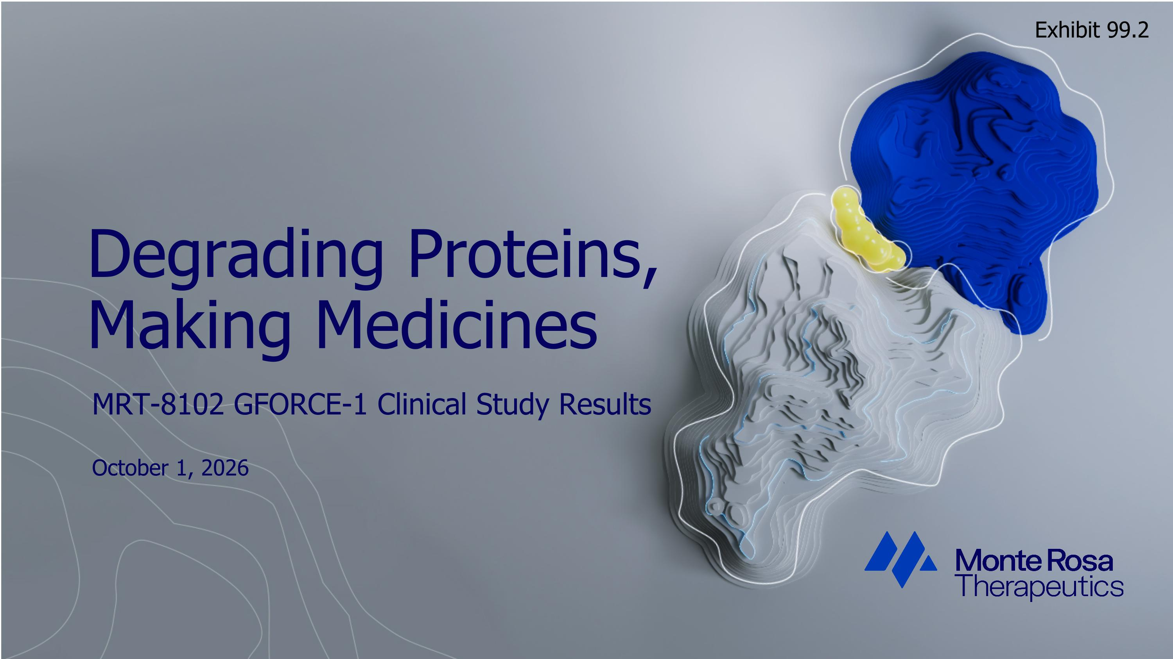
Degrading Proteins, ?Making Medicines MRT-8102 GFORCE-1 Clinical Study Results October 1, 2026 Exhibit 99.2

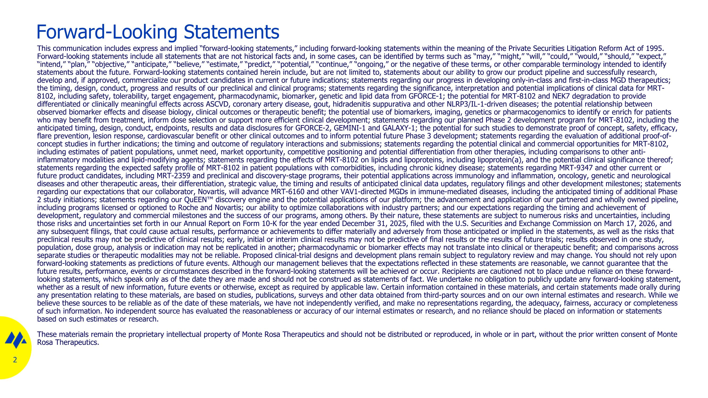
Forward-Looking Statements This communication includes express and implied “forward-looking statements,” including forward-looking statements within the meaning of the Private Securities Litigation Reform Act of 1995. Forward-looking statements include all statements that are not historical facts and, in some cases, can be identified by terms such as “may,” “might,” “will,” “could,” “would,” “should,” “expect,” “intend,” “plan,” “objective,” “anticipate,” “believe,” “estimate,” “predict,” “potential,” “continue,” “ongoing,” or the negative of these terms, or other comparable terminology intended to identify statements about the future. Forward-looking statements contained herein include, but are not limited to, statements about our ability to grow our product pipeline and successfully research, develop and, if approved, commercialize our product candidates in current or future indications; statements regarding our progress in developing only-in-class and first-in-class MGD therapeutics; the timing, design, conduct, progress and results of our preclinical and clinical programs; statements regarding the significance, interpretation and potential implications of clinical data for MRT-8102, including safety, tolerability, target engagement, pharmacodynamic, biomarker, genetic and lipid data from GFORCE-1; the potential for MRT-8102 and NEK7 degradation to provide differentiated or clinically meaningful effects across ASCVD, coronary artery disease, gout, hidradenitis suppurativa and other NLRP3/IL-1-driven diseases; the potential relationship between observed biomarker effects and disease biology, clinical outcomes or therapeutic benefit; the potential use of biomarkers, imaging, genetics or pharmacogenomics to identify or enrich for patients who may benefit from treatment, inform dose selection or support more efficient clinical development; statements regarding our planned Phase 2 development program for MRT-8102, including the anticipated timing, design, conduct, endpoints, results and data disclosures for GFORCE-2, GEMINI-1 and GALAXY-1; the potential for such studies to demonstrate proof of concept, safety, efficacy, flare prevention, lesion response, cardiovascular benefit or other clinical outcomes and to inform potential future Phase 3 development; statements regarding the evaluation of additional proof-of-concept studies in further indications; the timing and outcome of regulatory interactions and submissions; statements regarding the potential clinical and commercial opportunities for MRT-8102, including estimates of patient populations, unmet need, market opportunity, competitive positioning and potential differentiation from other therapies, including comparisons to other anti-inflammatory modalities and lipid-modifying agents; statements regarding the effects of MRT-8102 on lipids and lipoproteins, including lipoprotein(a), and the potential clinical significance thereof; statements regarding the expected safety profile of MRT-8102 in patient populations with comorbidities, including chronic kidney disease; statements regarding MRT-9347 and other current or future product candidates, including MRT-2359 and preclinical and discovery-stage programs, their potential applications across immunology and inflammation, oncology, genetic and neurological diseases and other therapeutic areas, their differentiation, strategic value, the timing and results of anticipated clinical data updates, regulatory filings and other development milestones; statements regarding our expectations that our collaborator, Novartis, will advance MRT-6160 and other VAV1-directed MGDs in immune-mediated diseases, including the anticipated timing of additional Phase 2 study initiations; statements regarding our QuEEN discovery engine and the potential applications of our platform; the advancement and application of our partnered and wholly owned pipeline, including programs licensed or optioned to Roche and Novartis; our ability to optimize collaborations with industry partners; and our expectations regarding the timing and achievement of development, regulatory and commercial milestones and the success of our programs, among others. By their nature, these statements are subject to numerous risks and uncertainties, including those risks and uncertainties set forth in our Annual Report on Form 10-K for the year ended December 31, 2025, filed with the U.S. Securities and Exchange Commission on March 17, 2026, and any subsequent filings, that could cause actual results, performance or achievements to differ materially and adversely from those anticipated or implied in the statements, as well as the risks that preclinical results may not be predictive of clinical results; early, initial or interim clinical results may not be predictive of final results or the results of future trials; results observed in one study, population, dose group, analysis or indication may not be replicated in another; pharmacodynamic or biomarker effects may not translate into clinical or therapeutic benefit; and comparisons across separate studies or therapeutic modalities may not be reliable. Proposed clinical-trial designs and development plans remain subject to regulatory review and may change. You should not rely upon forward-looking statements as predictions of future events. Although our management believes that the expectations reflected in these statements are reasonable, we cannot guarantee that the future results, performance, events or circumstances described in the forward-looking statements will be achieved or occur. Recipients are cautioned not to place undue reliance on these forward-looking statements, which speak only as of the date they are made and should not be construed as statements of fact. We undertake no obligation to publicly update any forward-looking statement, whether as a result of new information, future events or otherwise, except as required by applicable law. Certain information contained in these materials, and certain statements made orally during any presentation relating to these materials, are based on studies, publications, surveys and other data obtained from third-party sources and on our own internal estimates and research. While we believe these sources to be reliable as of the date of these materials, we have not independently verified, and make no representations regarding, the adequacy, fairness, accuracy or completeness of such information. No independent source has evaluated the reasonableness or accuracy of our internal estimates or research, and no reliance should be placed on information or statements based on such estimates or research. These materials remain the proprietary intellectual property of Monte Rosa Therapeutics and should not be distributed or reproduced, in whole or in part, without the prior written consent of Monte Rosa Therapeutics.

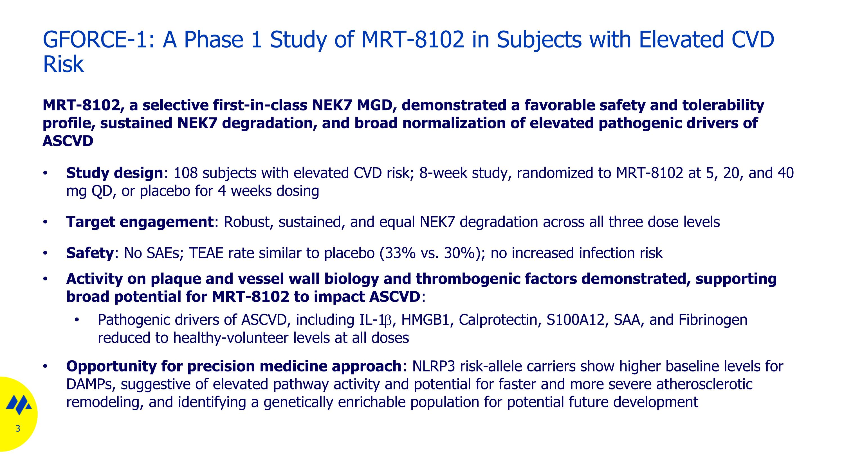
MRT-8102, a selective first-in-class NEK7 MGD, demonstrated a favorable safety and tolerability profile, sustained NEK7 degradation, and broad normalization of elevated pathogenic drivers of ASCVD Study design: 108 subjects with elevated CVD risk; 8-week study, randomized to MRT-8102 at 5, 20, and 40 mg QD, or placebo for 4 weeks dosing Target engagement: Robust, sustained, and equal NEK7 degradation across all three dose levels Safety: No SAEs; TEAE rate similar to placebo (33% vs. 30%); no increased infection risk Activity on plaque and vessel wall biology and thrombogenic factors demonstrated, supporting broad potential for MRT-8102 to impact ASCVD: Pathogenic drivers of ASCVD, including IL-1b, HMGB1, Calprotectin, S100A12, SAA, and Fibrinogen reduced to healthy-volunteer levels at all doses Opportunity for precision medicine approach: NLRP3 risk-allele carriers show higher baseline levels for DAMPs, suggestive of elevated pathway activity and potential for faster and more severe atherosclerotic remodeling, and identifying a genetically enrichable population for potential future development GFORCE-1: A Phase 1 Study of MRT-8102 in Subjects with Elevated CVD Risk

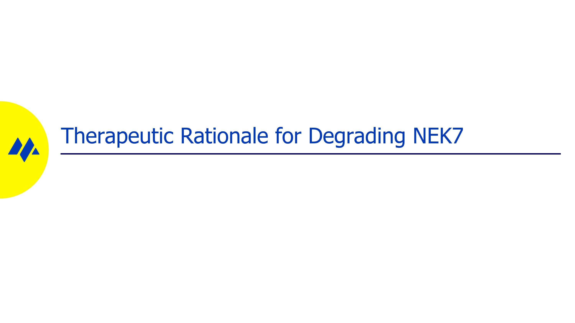
Therapeutic Rationale for Degrading NEK7

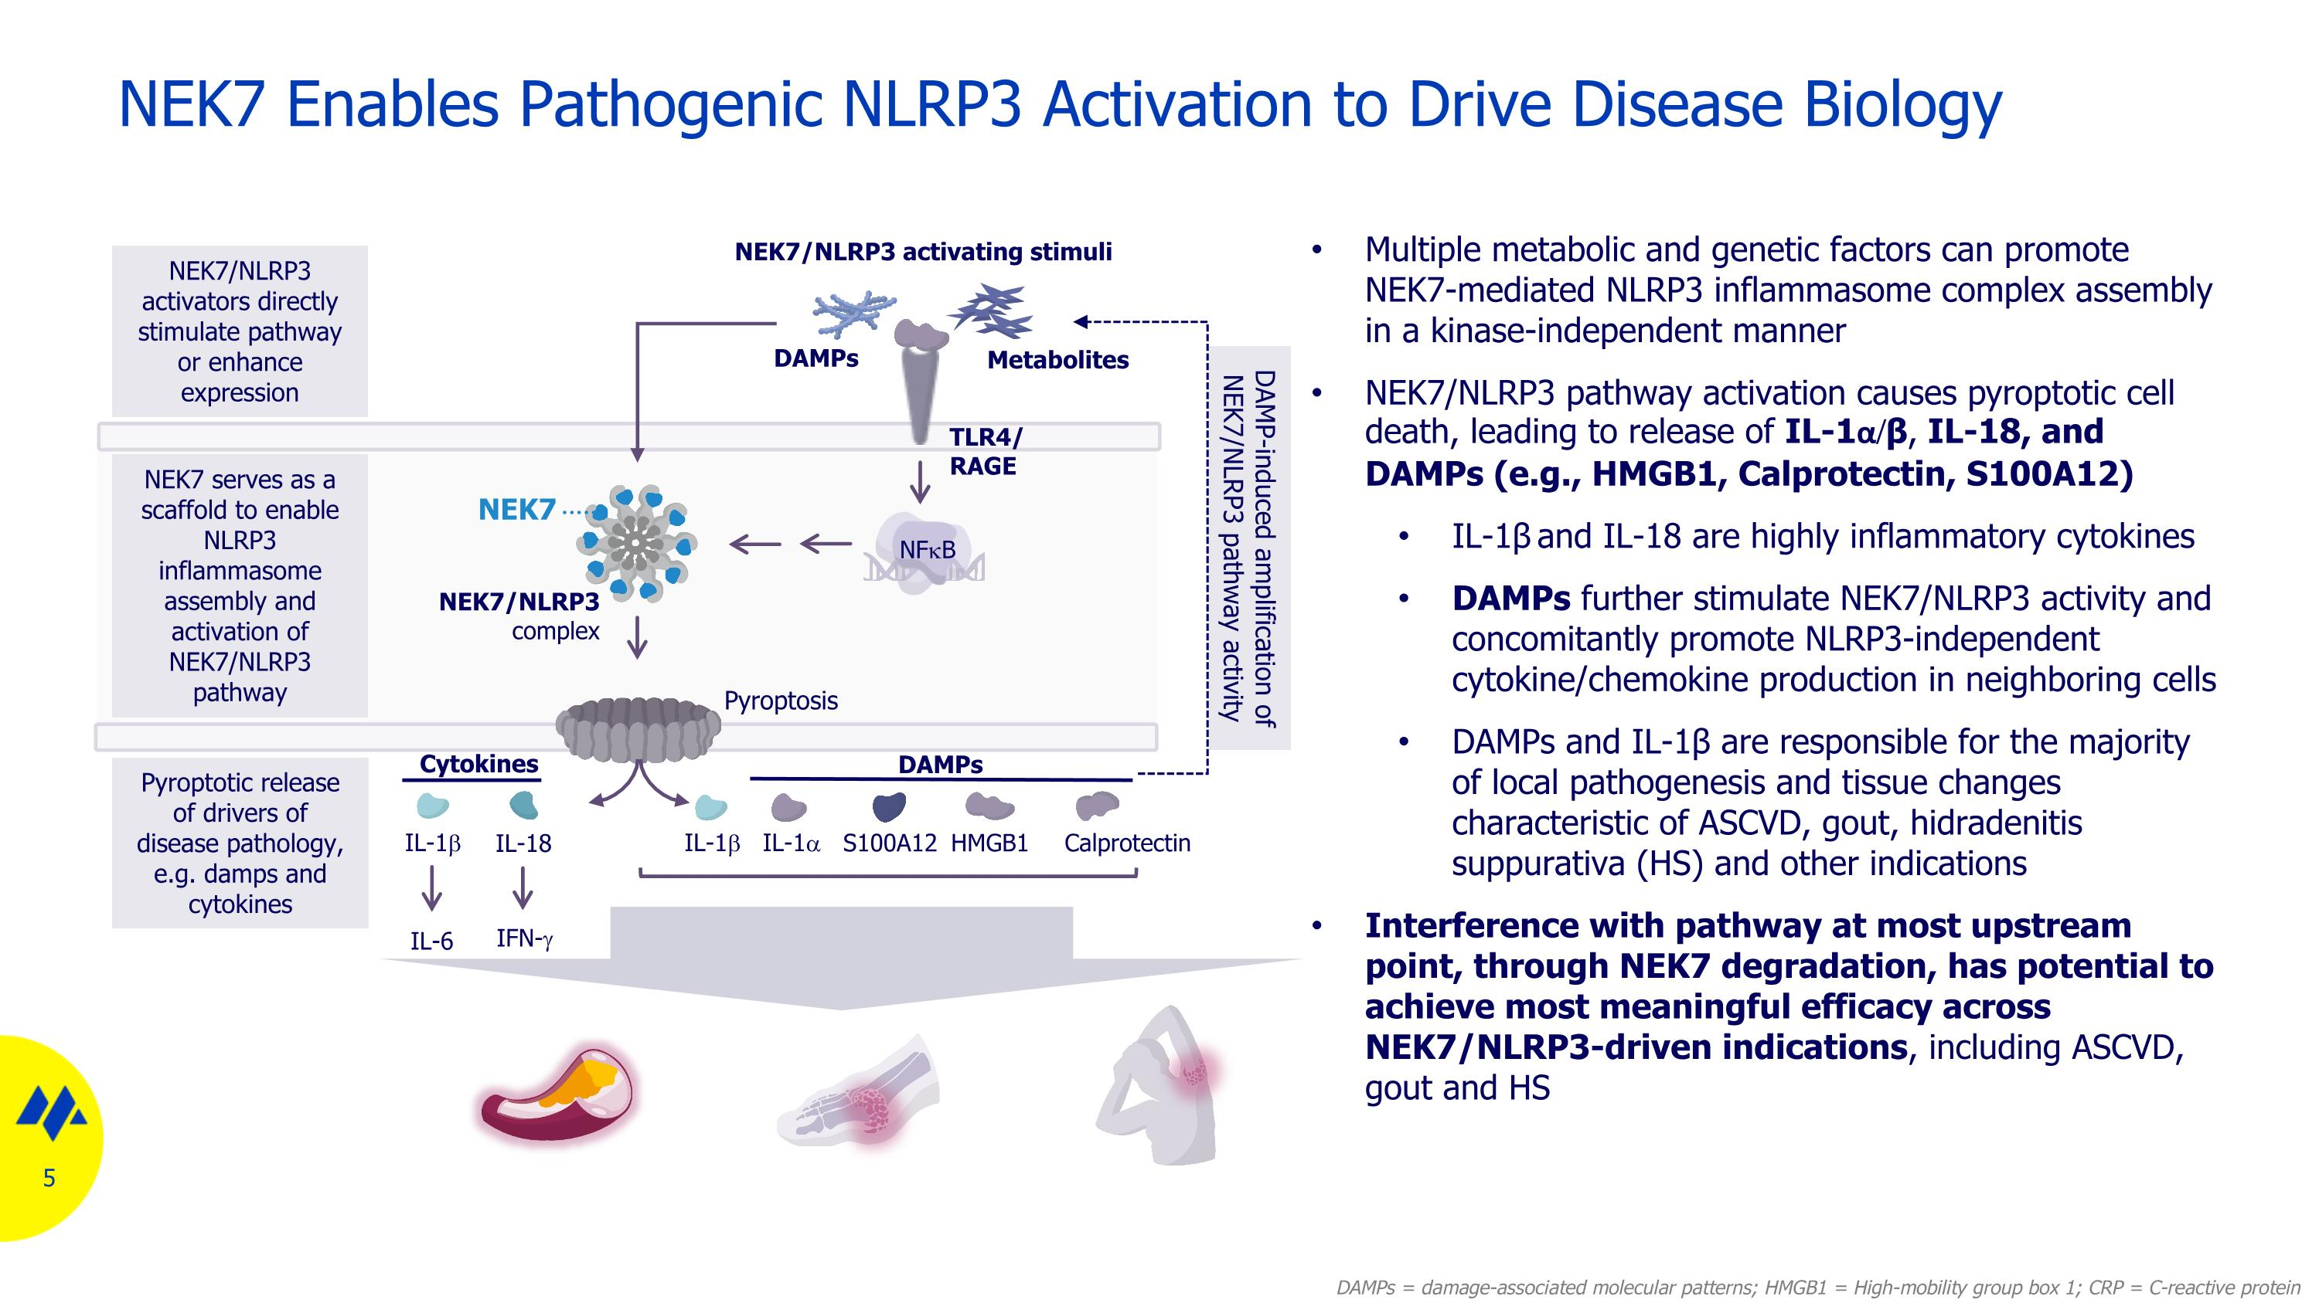
NEK7 Enables Pathogenic NLRP3 Activation to Drive Disease Biology Multiple metabolic and genetic factors can promote NEK7-mediated NLRP3 inflammasome complex assembly in a kinase-independent manner NEK7/NLRP3 pathway activation causes pyroptotic cell death, leading to release of IL-1α/β, IL-18, and DAMPs (e.g., HMGB1, Calprotectin, S100A12) IL-1β and IL-18 are highly inflammatory cytokines DAMPs further stimulate NEK7/NLRP3 activity and concomitantly promote NLRP3-independent cytokine/chemokine production in neighboring cells DAMPs and IL-1β are responsible for the majority of local pathogenesis and tissue changes characteristic of ASCVD, gout, hidradenitis suppurativa (HS) and other indications Interference with pathway at most upstream point, through NEK7 degradation, has potential to achieve most meaningful efficacy across NEK7/NLRP3-driven indications, including ASCVD, gout and HS DAMPs = damage-associated molecular patterns; HMGB1 = High-mobility group box 1; CRP = C-reactive protein NEK7 NEK7/NLRP3 complex Pyroptosis IL-1b Calprotectin Cytokines DAMPs DAMP-induced amplification of NEK7/NLRP3 pathway activity IL-1b NFkB NEK7/NLRP3 activating stimuli S100A12 DAMPs TLR4/ RAGE HMGB1 IL-1a Pyroptotic release of drivers of disease pathology, e.g. damps and cytokines NEK7 serves as a scaffold to enable NLRP3 inflammasome assembly and activation of NEK7/NLRP3 pathway NEK7/NLRP3 activators directly stimulate pathway or enhance expression Metabolites IL-6 IL-18 IFN-g

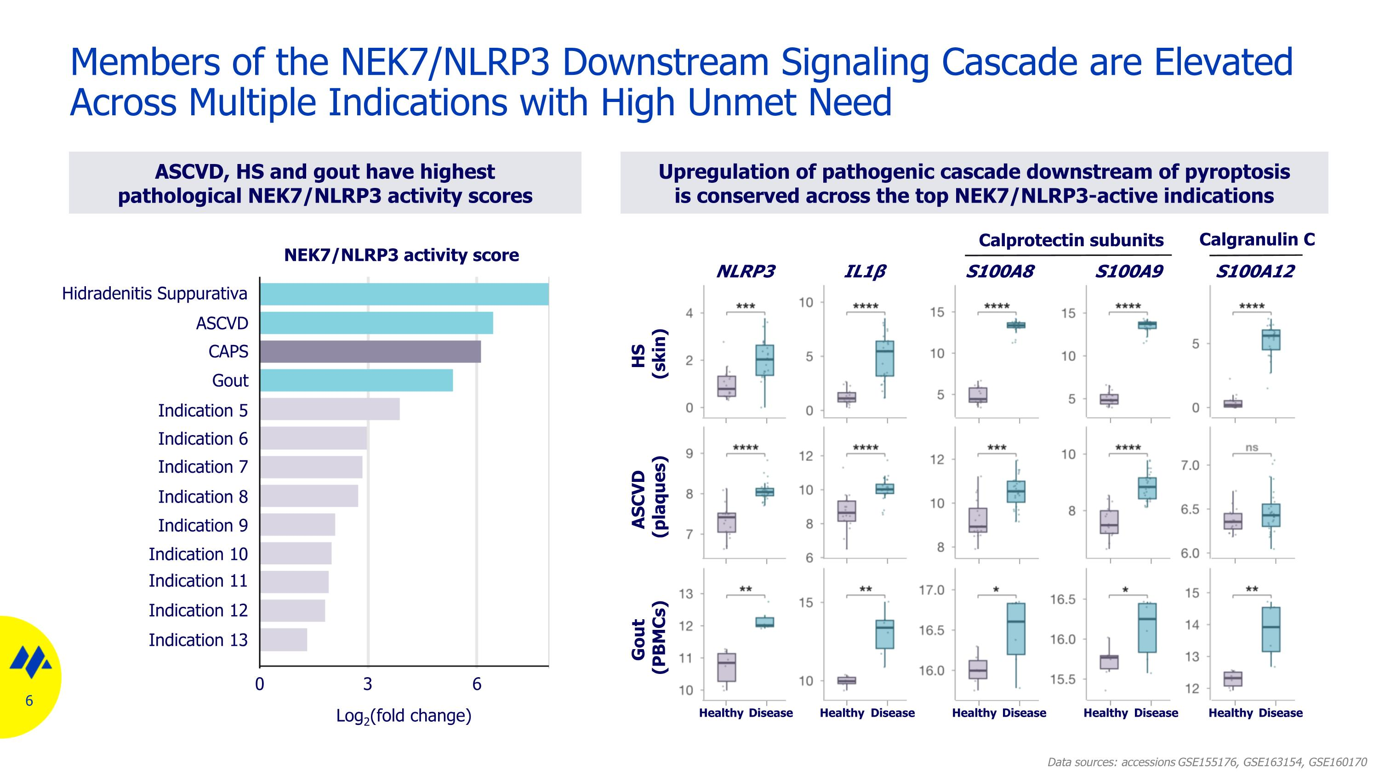
Members of the NEK7/NLRP3 Downstream Signaling Cascade are Elevated Across Multiple Indications with High Unmet Need Upregulation of pathogenic cascade downstream of pyroptosis ?is conserved across the top NEK7/NLRP3-active indications ASCVD, HS and gout have highest pathological NEK7/NLRP3 activity scores HS (skin) ASCVD (plaques) Gout (PBMCs) NLRP3 IL1β S100A8 S100A9 Healthy Disease Healthy Disease Healthy Disease Healthy Disease Hidradenitis Suppurativa ASCVD CAPS Gout Indication 5 Indication 6 Indication 7 Indication 8 Indication 9 Indication 10 Indication 11 Indication 12 Indication 13 Data sources: accessions GSE155176, GSE163154, GSE160170 S100A12 Healthy Disease 0 3 6 Calprotectin subunits Calgranulin C NEK7/NLRP3 activity score Log2(fold change)

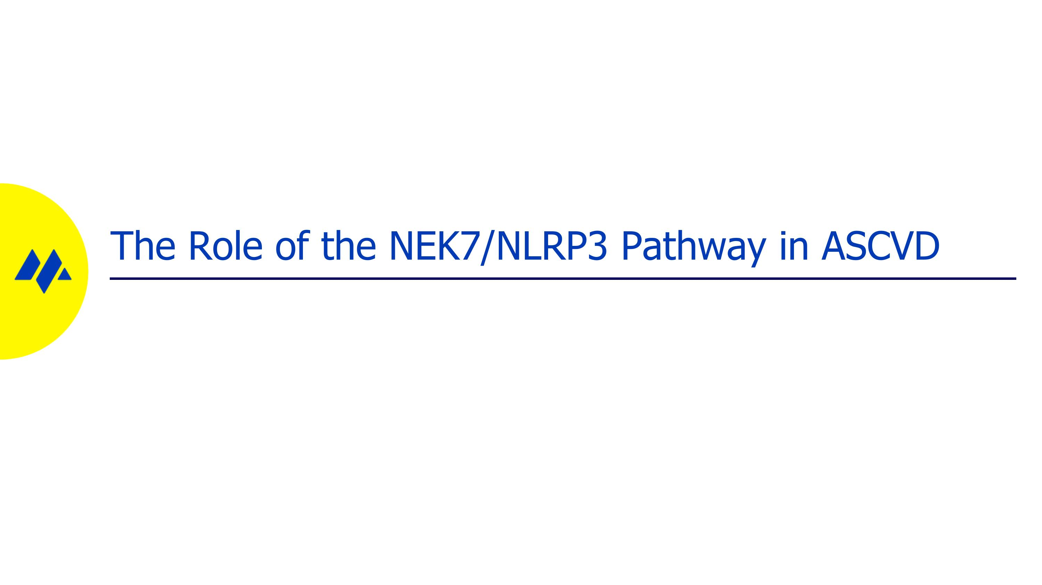
The Role of the NEK7/NLRP3 Pathway in ASCVD

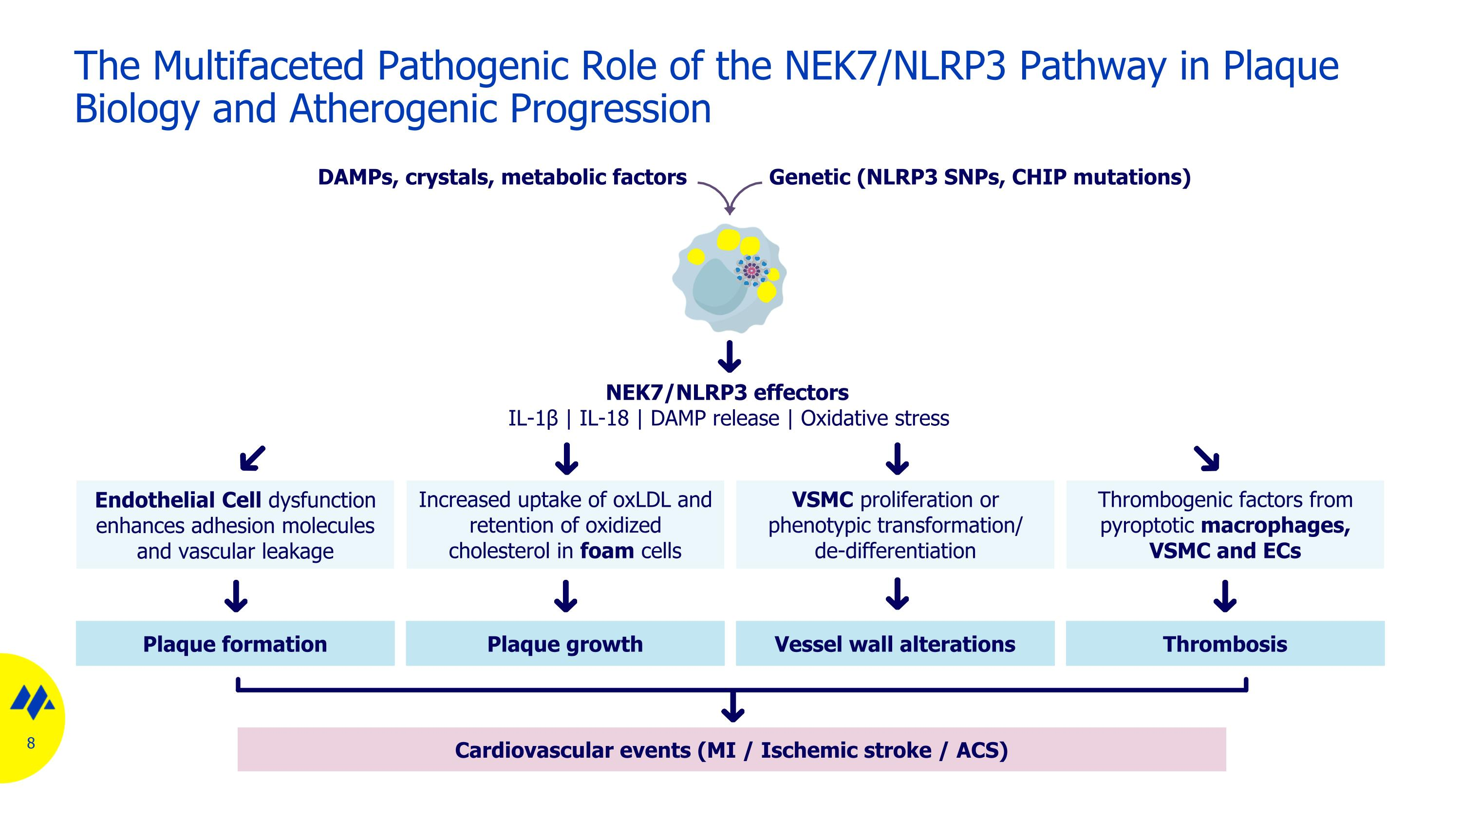
The Multifaceted Pathogenic Role of the NEK7/NLRP3 Pathway in Plaque Biology and Atherogenic Progression Endothelial Cell dysfunction enhances adhesion molecules and vascular leakage Increased uptake of oxLDL and retention of oxidized cholesterol in foam cells VSMC proliferation or phenotypic transformation/ de-differentiation Thrombogenic factors from pyroptotic macrophages, VSMC and ECs Plaque formation Plaque growth Vessel wall alterations Thrombosis Cardiovascular events (MI / Ischemic stroke / ACS) NEK7/NLRP3 effectors IL-1β | IL-18 | DAMP release | Oxidative stress DAMPs, crystals, metabolic factors Genetic (NLRP3 SNPs, CHIP mutations)

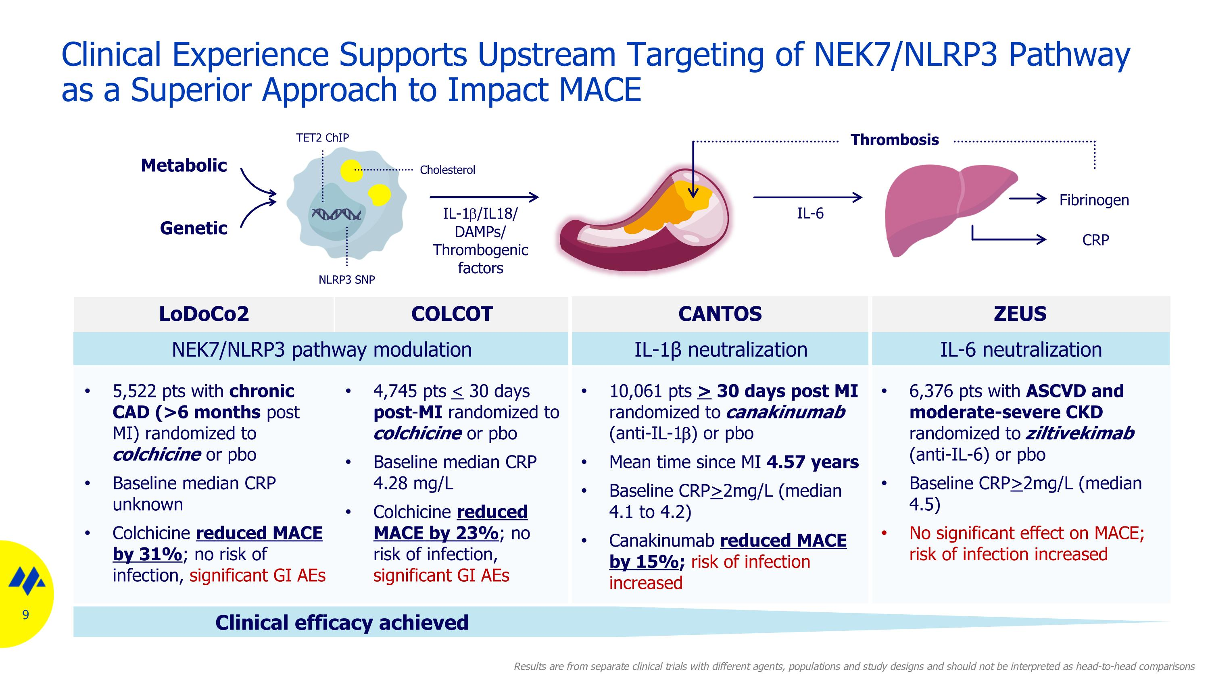
Clinical Experience Supports Upstream Targeting of NEK7/NLRP3 Pathway as a Superior Approach to Impact MACE Clinical efficacy achieved NLRP3 SNP TET2 ChIP Metabolic Genetic Cholesterol LoDoCo2 COLCOT CANTOS ZEUS NEK7/NLRP3 pathway modulation IL-1β neutralization IL-6 neutralization 5,522 pts with chronic CAD (>6 months post MI) randomized to colchicine or pbo Baseline median CRP unknown Colchicine reduced MACE by 31%; no risk of infection, significant GI AEs 4,745 pts < 30 days post-MI randomized to colchicine or pbo Baseline median CRP 4.28 mg/L Colchicine reduced MACE by 23%; no risk of infection, significant GI AEs 10,061 pts > 30 days post MI randomized to canakinumab (anti-IL-1b) or pbo Mean time since MI 4.57 years Baseline CRP>2mg/L (median 4.1 to 4.2) Canakinumab reduced MACE by 15%; risk of infection increased 6,376 pts with ASCVD and moderate-severe CKD randomized to ziltivekimab (anti-IL-6) or pbo Baseline CRP>2mg/L (median 4.5) No significant effect on MACE; risk of infection increased IL-1b/IL18/ DAMPs/ Thrombogenic factors IL-6 Fibrinogen CRP Thrombosis Results are from separate clinical trials with different agents, populations and study designs and should not be interpreted as head-to-head comparisons

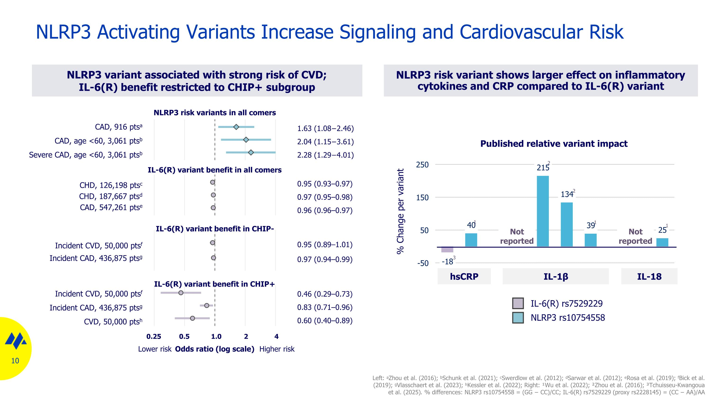
NLRP3 Activating Variants Increase Signaling and Cardiovascular Risk NLRP3 risk variant shows larger effect on inflammatory cytokines and CRP compared to IL-6(R) variant NLRP3 variant associated with strong risk of CVD; IL-6(R) benefit restricted to CHIP+ subgroup NLRP3 risk variants in all comers IL-6(R) variant benefit in all comers IL-6(R) variant benefit in CHIP- IL-6(R) variant benefit in CHIP+ Odds ratio (log scale) hsCRP IL-1β IL-18 % Change per variant CAD, 916 ptsa?CAD, age <60, 3,061 ptsb?Severe CAD, age <60, 3,061 ptsb CHD, 126,198 ptsc?CHD, 187,667 ptsd?CAD, 547,261 ptse Incident CVD, 50,000 ptsf?Incident CAD, 436,875 ptsg Incident CVD, 50,000 ptsf?Incident CAD, 436,875 ptsg?CVD, 50,000 ptsh 0.95 (0.93–0.97) 0.97 (0.95–0.98) 0.96 (0.96–0.97) 1.63 (1.08−2.46) 2.04 (1.15−3.61) 2.28 (1.29−4.01) 0.46 (0.29–0.73) 0.83 (0.71–0.96) 0.60 (0.40–0.89) 0.95 (0.89–1.01) 0.97 (0.94–0.99) 0.25 0.5 2 4 1.0 Lower risk Higher risk 1 1 1 2 2 3 IL-6(R) rs7529229 NLRP3 rs10754558 Left: ᵃZhou et al. (2016); ᵇSchunk et al. (2021); ᶜSwerdlow et al. (2012); ᵈSarwar et al. (2012); ᵉRosa et al. (2019); ᶠBick et al. (2019); ᵍVlasschaert et al. (2023); ʰKessler et al. (2022); Right: ¹Wu et al. (2022); ²Zhou et al. (2016); ³Tchuisseu-Kwangoua et al. (2025). % differences: NLRP3 rs10754558 = (GG − CC)/CC; IL-6(R) rs7529229 (proxy rs2228145) = (CC − AA)/AA Not reported Not reported Published relative variant impact

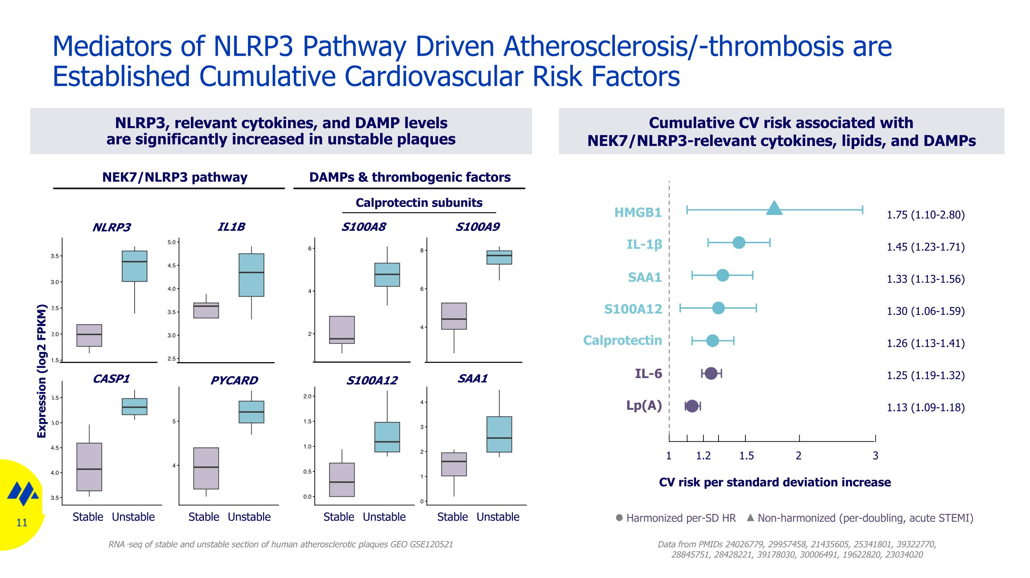
Mediators of NLRP3 Pathway Driven Atherosclerosis/-thrombosis are Established Cumulative Cardiovascular Risk Factors NLRP3, relevant cytokines, and DAMP levels are significantly increased in unstable plaques NEK7/NLRP3 pathway DAMPs & thrombogenic factors Data from PMIDs 24026779, 29957458, 21435605, 25341801, 39322770, 28845751, 28428221, 39178030, 30006491, 19622820, 23034020 Cumulative CV risk associated with NEK7/NLRP3-relevant cytokines, lipids, and DAMPs CV risk per standard deviation increase Harmonized per-SD HR Non-harmonized (per-doubling, acute STEMI) HMGB1 IL-1β S100A12 SAA1 RNA-seq of stable and unstable section of human atherosclerotic plaques GEO GSE120521 1 1.2 1.5 2 3 Stable Unstable Stable Unstable Stable Unstable Stable Unstable Expression (log2 FPKM) IL-6 Lp(A) Calprotectin subunits NLRP3 IL1B S100A8 S100A9 CASP1 PYCARD S100A12 SAA1 1.75 (1.10-2.80)?1.45 (1.23-1.71)?1.33 (1.13-1.56)?1.30 (1.06-1.59)?1.26 (1.13-1.41)?1.25 (1.19-1.32)?1.13 (1.09-1.18) Calprotectin


Results of GFORCE-1 Study

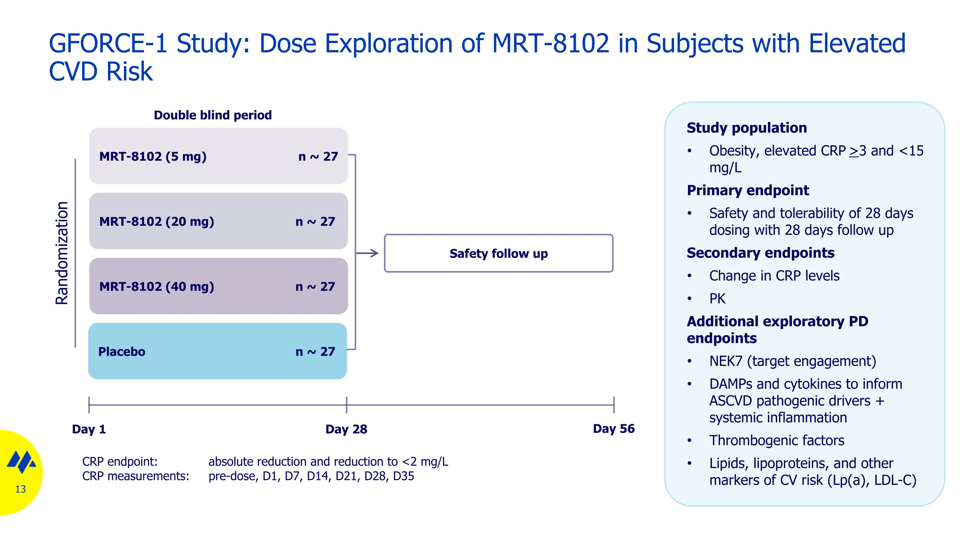
GFORCE-1 Study: Dose Exploration of MRT-8102 in Subjects with Elevated CVD Risk Double blind period CRP endpoint: absolute reduction and reduction to <2 mg/L CRP measurements: pre-dose, D1, D7, D14, D21, D28, D35 Placebo n ~ 27 MRT-8102 (40 mg) n ~ 27 Randomization Day 56 Day 28 Day 1 Safety follow up Study population Obesity, elevated CRP >3 and <15 mg/L Primary endpoint Safety and tolerability of 28 days dosing with 28 days follow up Secondary endpoints Change in CRP levels PK Additional exploratory PD endpoints NEK7 (target engagement) DAMPs and cytokines to inform ASCVD pathogenic drivers + systemic inflammation Thrombogenic factors Lipids, lipoproteins, and other markers of CV risk (Lp(a), LDL-C) MRT-8102 (20 mg) n ~ 27 MRT-8102 (5 mg) n ~ 27

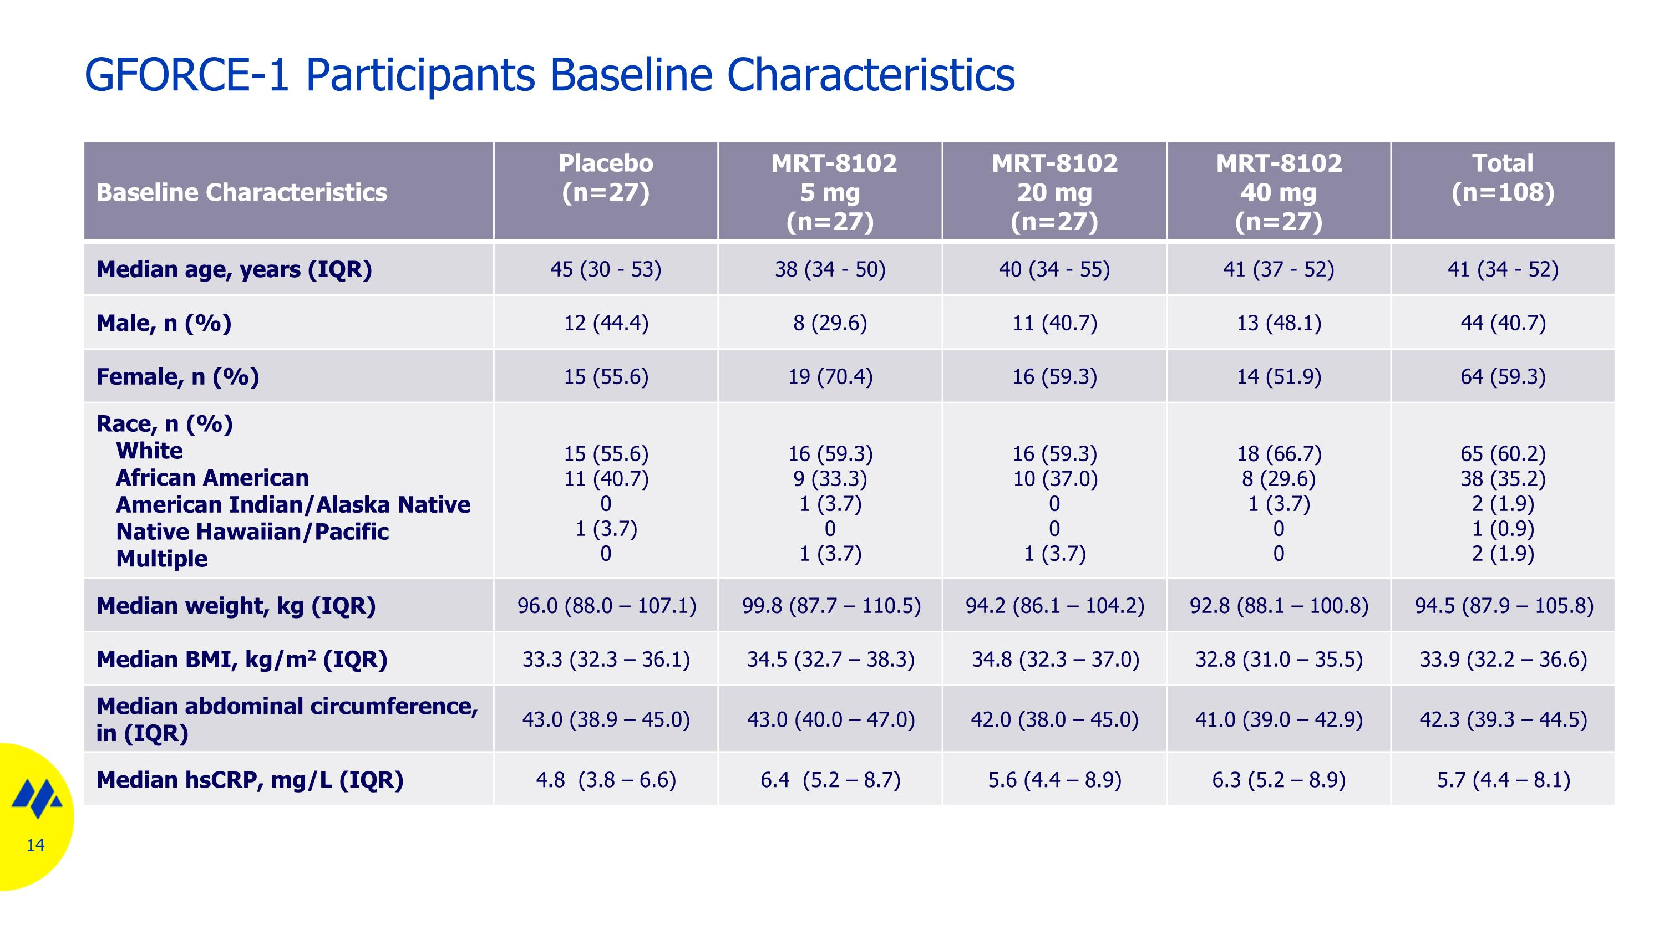
GFORCE-1 Participants Baseline Characteristics Baseline Characteristics Placebo (n=27) MRT-8102 5 mg (n=27) MRT-8102 20 mg (n=27) MRT-8102 40 mg (n=27) Total (n=108) Median age, years (IQR) 45 (30 - 53) 38 (34 - 50) 40 (34 - 55) 41 (37 - 52) 41 (34 - 52) Male, n (%) 12 (44.4) 8 (29.6) 11 (40.7) 13 (48.1) 44 (40.7) Female, n (%) 15 (55.6) 19 (70.4) 16 (59.3) 14 (51.9) 64 (59.3) Race, n (%) White African American American Indian/Alaska Native Native Hawaiian/Pacific Multiple 15 (55.6) 11 (40.7) 0 1 (3.7) 0 16 (59.3) 9 (33.3) 1 (3.7) 0 1 (3.7) 16 (59.3) 10 (37.0) 0 0 1 (3.7) 18 (66.7) 8 (29.6) 1 (3.7) 0 0 65 (60.2) 38 (35.2) 2 (1.9) 1 (0.9) 2 (1.9) Median weight, kg (IQR) 96.0 (88.0 – 107.1) 99.8 (87.7 – 110.5) 94.2 (86.1 – 104.2) 92.8 (88.1 – 100.8) 94.5 (87.9 – 105.8) Median BMI, kg/m2 (IQR) 33.3 (32.3 – 36.1) 34.5 (32.7 – 38.3) 34.8 (32.3 – 37.0) 32.8 (31.0 – 35.5) 33.9 (32.2 – 36.6) Median abdominal circumference, in (IQR) 43.0 (38.9 – 45.0) 43.0 (40.0 – 47.0) 42.0 (38.0 – 45.0) 41.0 (39.0 – 42.9) 42.3 (39.3 – 44.5) Median hsCRP, mg/L (IQR) 4.8 (3.8 – 6.6) 6.4 (5.2 – 8.7) 5.6 (4.4 – 8.9) 6.3 (5.2 – 8.9) 5.7 (4.4 – 8.1)

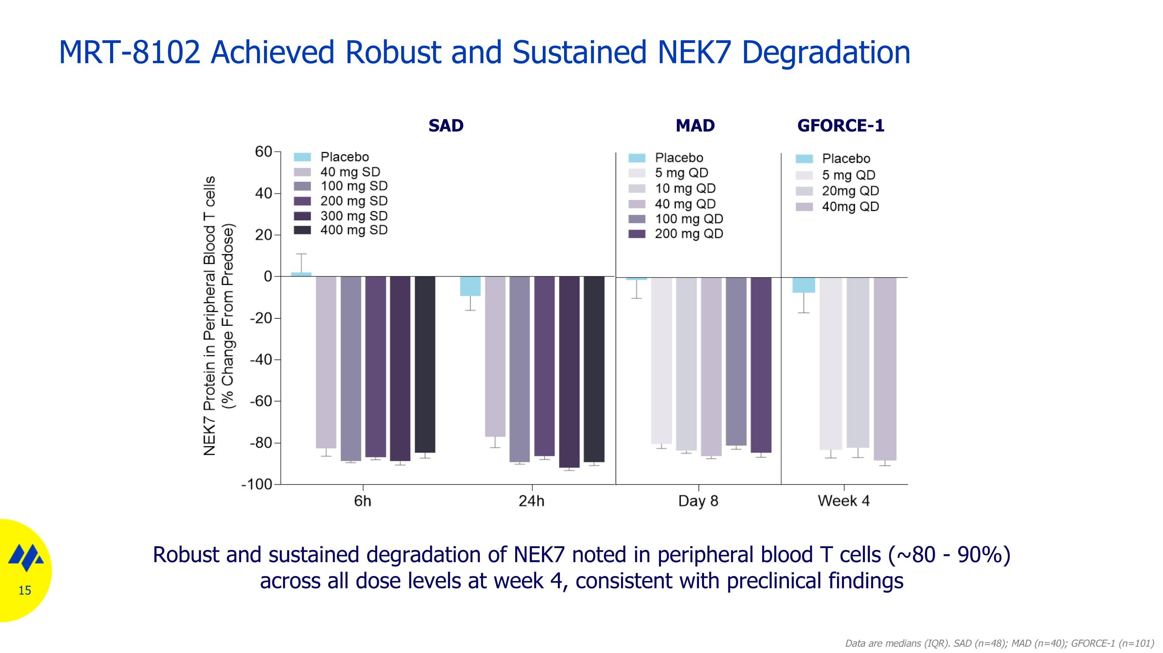
MRT-8102 Achieved Robust and Sustained NEK7 Degradation Robust and sustained degradation of NEK7 noted in peripheral blood T cells (~80 - 90%) across all dose levels at week 4, consistent with preclinical findings Data are medians (IQR). SAD (n=48); MAD (n=40); GFORCE-1 (n=101) SAD MAD GFORCE-1

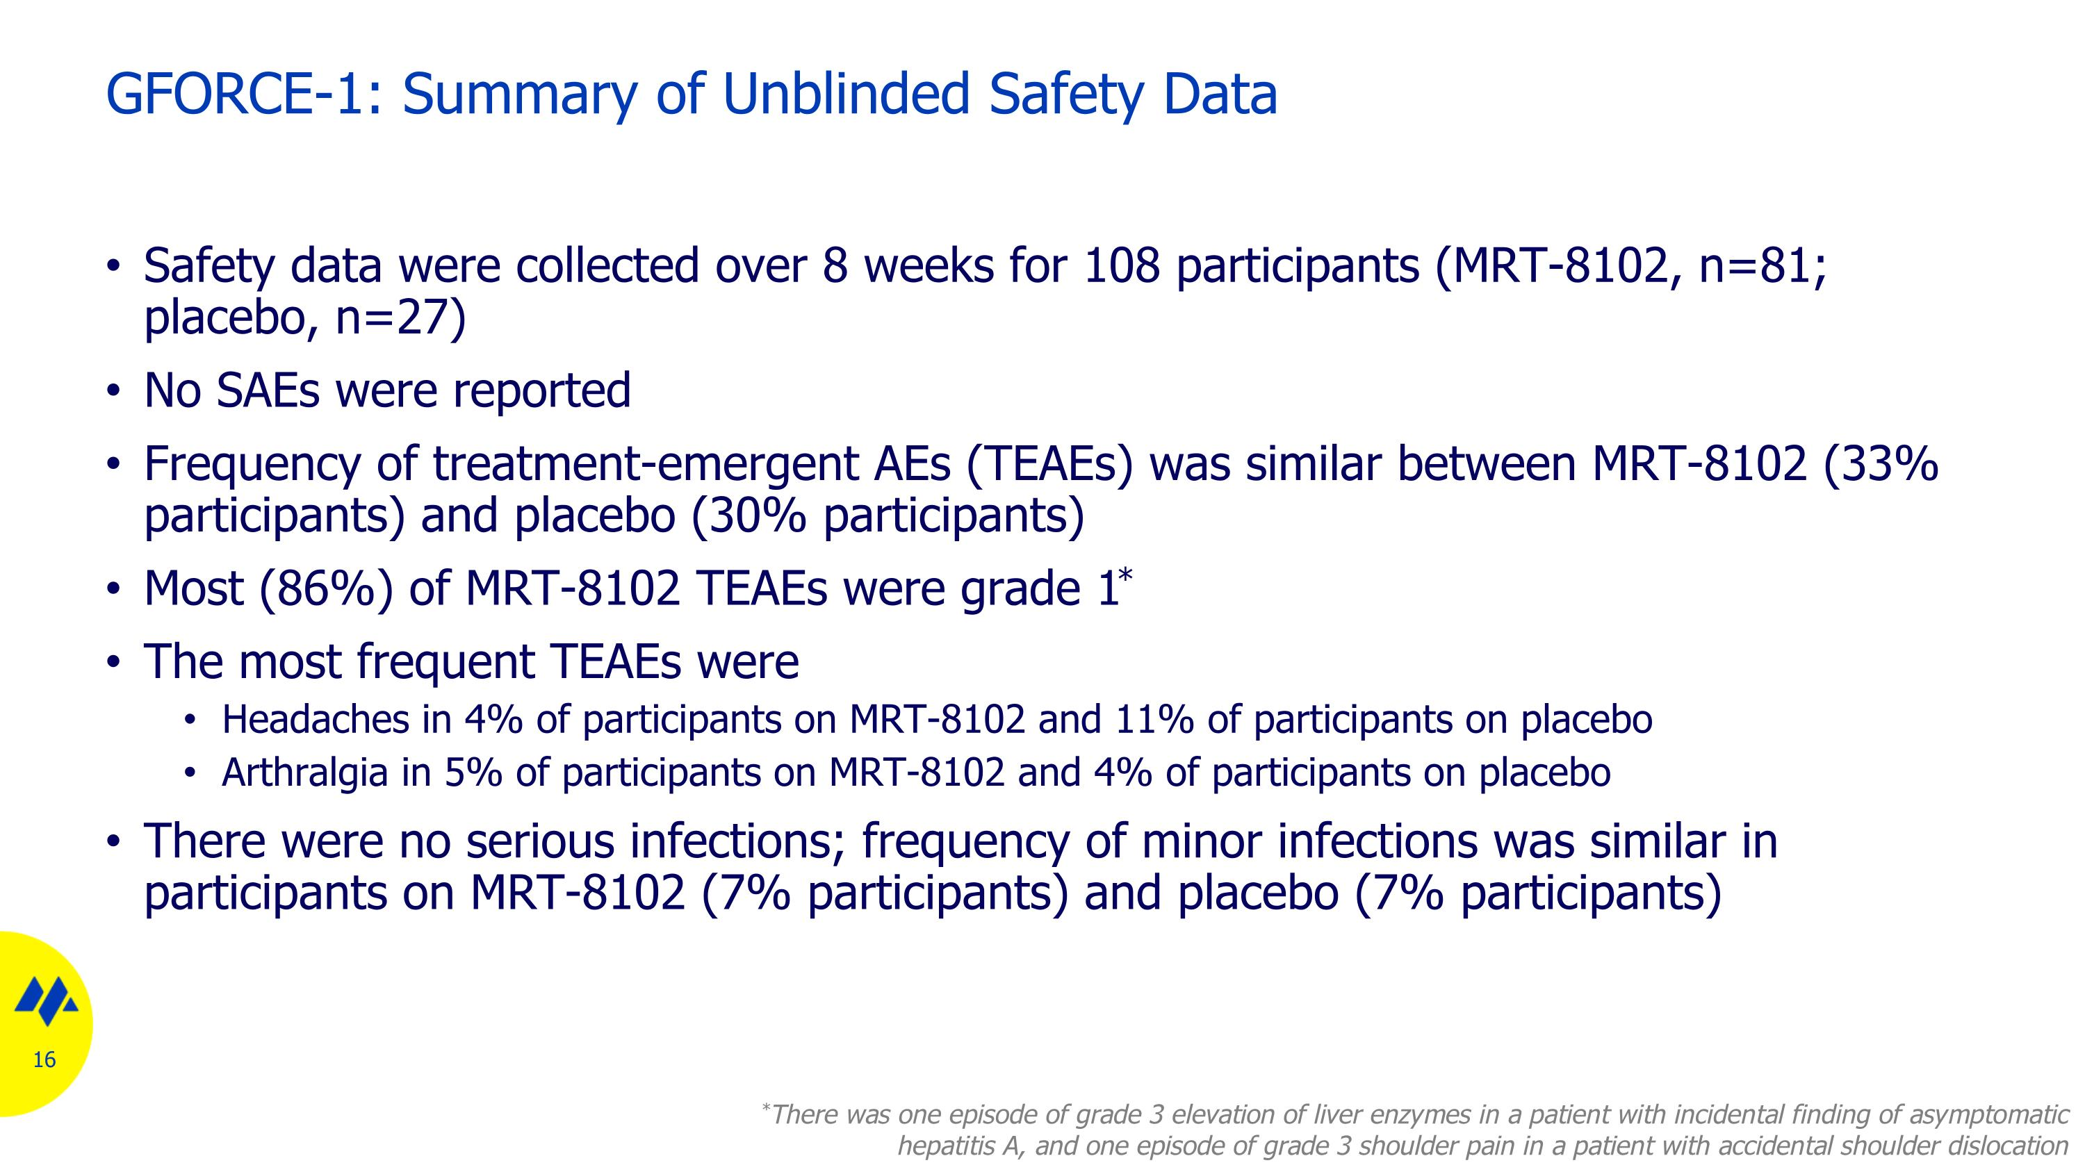
Safety data were collected over 8 weeks for 108 participants (MRT-8102, n=81; placebo, n=27) No SAEs were reported Frequency of treatment-emergent AEs (TEAEs) was similar between MRT-8102 (33% participants) and placebo (30% participants) Most (86%) of MRT-8102 TEAEs were grade 1* The most frequent TEAEs were Headaches in 4% of participants on MRT-8102 and 11% of participants on placebo Arthralgia in 5% of participants on MRT-8102 and 4% of participants on placebo There were no serious infections; frequency of minor infections was similar in participants on MRT-8102 (7% participants) and placebo (7% participants) GFORCE-1: Summary of Unblinded Safety Data *There was one episode of grade 3 elevation of liver enzymes in a patient with incidental finding of asymptomatic hepatitis A, and one episode of grade 3 shoulder pain in a patient with accidental shoulder dislocation

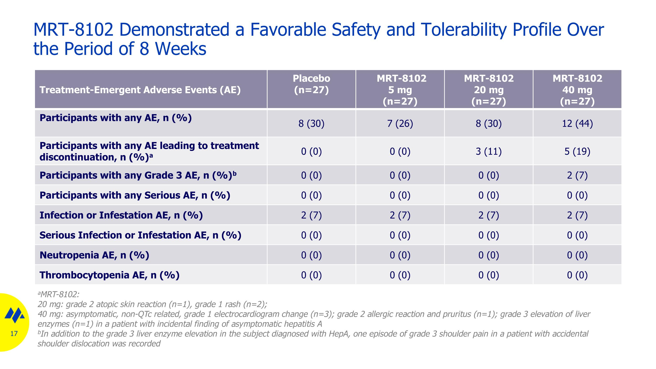
MRT-8102 Demonstrated a Favorable Safety and Tolerability Profile Over the Period of 8 Weeks Treatment-Emergent Adverse Events (AE) Placebo (n=27) MRT-8102 5 mg (n=27) MRT-8102 20 mg (n=27) MRT-8102 40 mg (n=27) Participants with any AE, n (%) 8 (30) 7 (26) 8 (30) 12 (44) Participants with any AE leading to treatment discontinuation, n (%)a 0 (0) 0 (0) 3 (11) 5 (19) Participants with any Grade 3 AE, n (%)b 0 (0) 0 (0) 0 (0) 2 (7) Participants with any Serious AE, n (%) 0 (0) 0 (0) 0 (0) 0 (0) Infection or Infestation AE, n (%) 2 (7) 2 (7) 2 (7) 2 (7) Serious Infection or Infestation AE, n (%) 0 (0) 0 (0) 0 (0) 0 (0) Neutropenia AE, n (%) 0 (0) 0 (0) 0 (0) 0 (0) Thrombocytopenia AE, n (%) 0 (0) 0 (0) 0 (0) 0 (0) aMRT-8102: 20 mg: grade 2 atopic skin reaction (n=1), grade 1 rash (n=2); 40 mg: asymptomatic, non-QTc related, grade 1 electrocardiogram change (n=3); grade 2 allergic reaction and pruritus (n=1); grade 3 elevation of liver enzymes (n=1) in a patient with incidental finding of asymptomatic hepatitis A bIn addition to the grade 3 liver enzyme elevation in the subject diagnosed with HepA, one episode of grade 3 shoulder pain in a patient with accidental shoulder dislocation was recorded

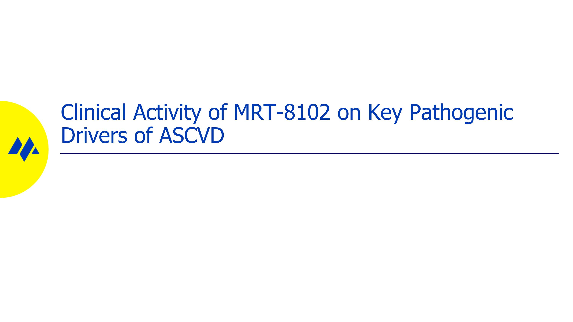
Clinical Activity of MRT-8102 on Key Pathogenic Drivers of ASCVD

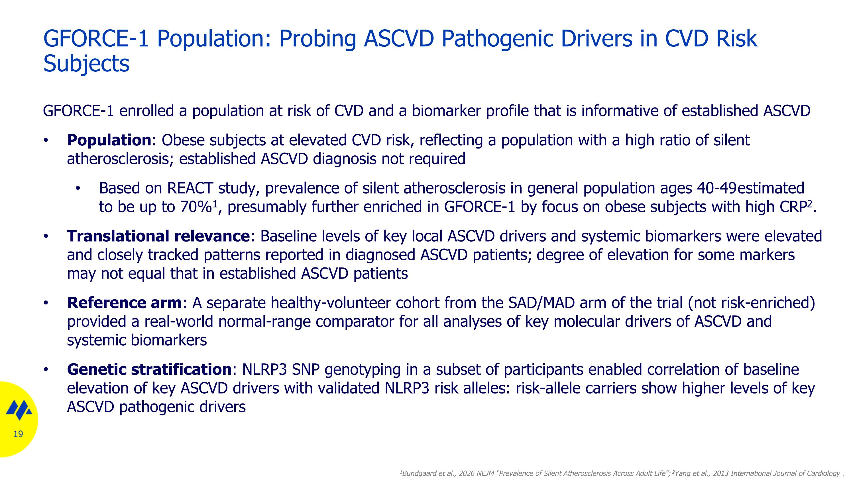
GFORCE-1 enrolled a population at risk of CVD and a biomarker profile that is informative of established ASCVD Population: Obese subjects at elevated CVD risk, reflecting a population with a high ratio of silent atherosclerosis; established ASCVD diagnosis not required Based on REACT study, prevalence of silent atherosclerosis in general population ages 40-49 estimated to be up to 70%1, presumably further enriched in GFORCE-1 by focus on obese subjects with high CRP2. Translational relevance: Baseline levels of key local ASCVD drivers and systemic biomarkers were elevated and closely tracked patterns reported in diagnosed ASCVD patients; degree of elevation for some markers may not equal that in established ASCVD patients Reference arm: A separate healthy-volunteer cohort from the SAD/MAD arm of the trial (not risk-enriched) provided a real-world normal-range comparator for all analyses of key molecular drivers of ASCVD and systemic biomarkers Genetic stratification: NLRP3 SNP genotyping in a subset of participants enabled correlation of baseline elevation of key ASCVD drivers with validated NLRP3 risk alleles: risk-allele carriers show higher levels of key ASCVD pathogenic drivers GFORCE-1 Population: Probing ASCVD Pathogenic Drivers in CVD Risk Subjects 1Bundgaard et al., 2026 NEJM “Prevalence of Silent Atherosclerosis Across Adult Life”; 2Yang et al., 2013 International Journal of Cardiology .

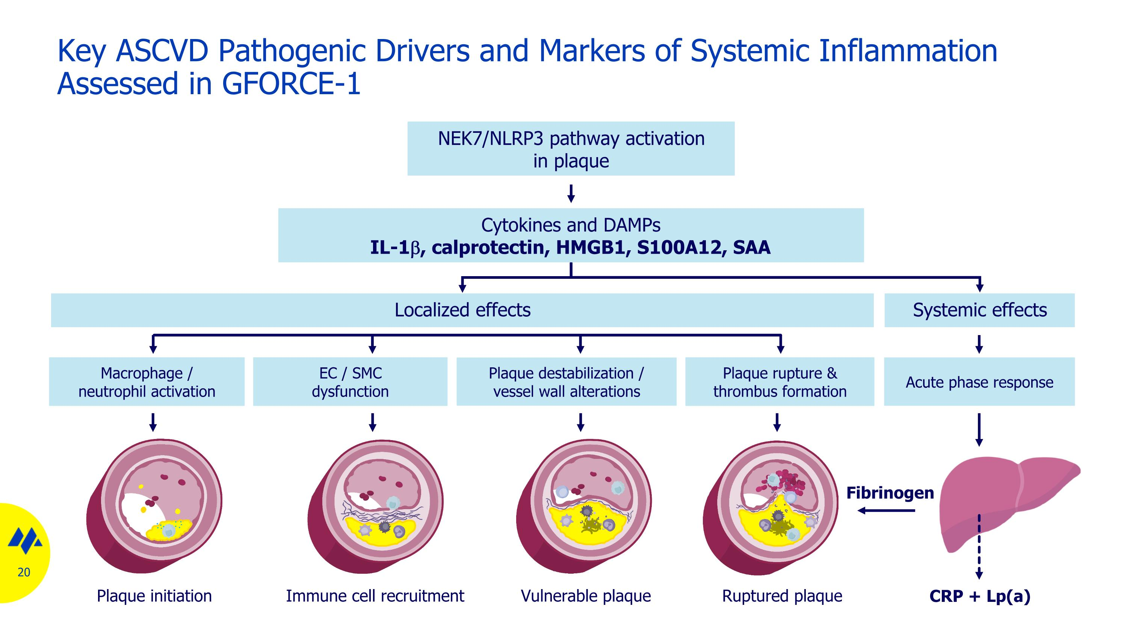
Macrophage / neutrophil activation Plaque destabilization / vessel wall alterations Plaque rupture & thrombus formation Acute phase response EC / SMC dysfunction Vulnerable plaque Immune cell recruitment Plaque initiation Ruptured plaque Fibrinogen CRP + Lp(a) Key ASCVD Pathogenic Drivers and Markers of Systemic Inflammation Assessed in GFORCE-1 NEK7/NLRP3 pathway activation in plaque Cytokines and DAMPs IL-1b, calprotectin, HMGB1, S100A12, SAA Localized effects Systemic effects

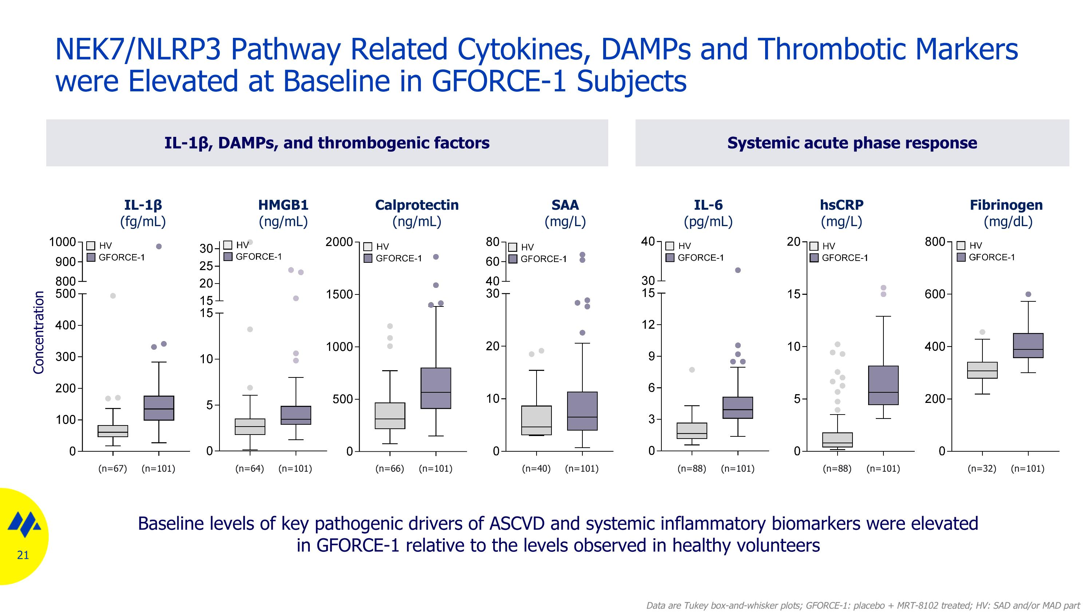
IL-1β, DAMPs, and thrombogenic factors NEK7/NLRP3 Pathway Related Cytokines, DAMPs and Thrombotic Markers were Elevated at Baseline in GFORCE-1 Subjects Calprotectin (ng/mL) HMGB1 (ng/mL) IL-6 (pg/mL) hsCRP (mg/L) SAA (mg/L) IL-1β (fg/mL) (n=67) (n=101) (n=64) (n=101) (n=66) (n=101) (n=40) (n=101) (n=88) (n=101) (n=88) (n=101) Data are Tukey box-and-whisker plots; GFORCE-1: placebo + MRT-8102 treated; HV: SAD and/or MAD part Systemic acute phase response Fibrinogen (mg/dL) (n=32) (n=101) Baseline levels of key pathogenic drivers of ASCVD and systemic inflammatory biomarkers were elevated in GFORCE-1 relative to the levels observed in healthy volunteers Concentration

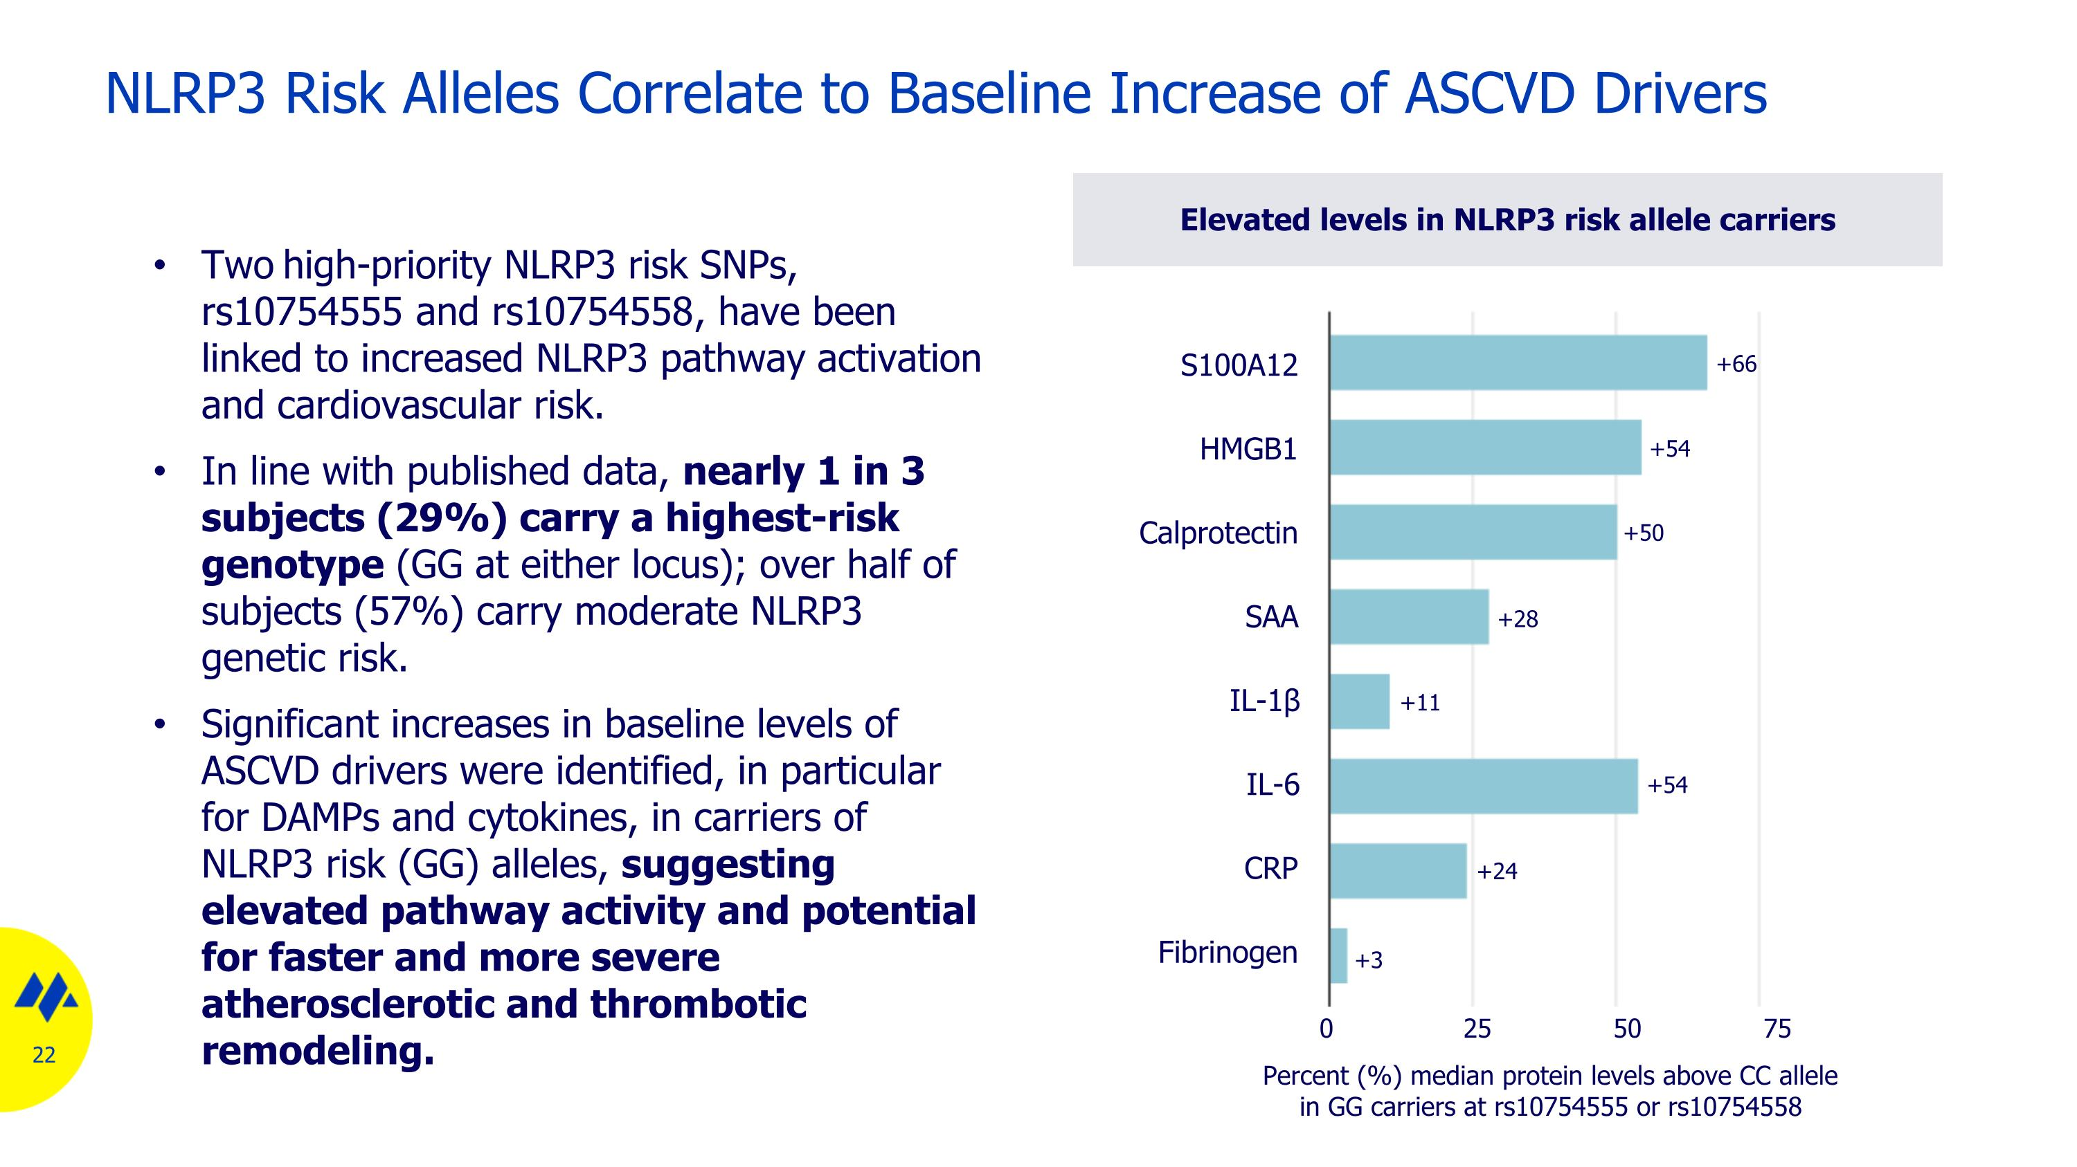
NLRP3 Risk Alleles Correlate to Baseline Increase of ASCVD Drivers Two high-priority NLRP3 risk SNPs, rs10754555 and rs10754558, have been linked to increased NLRP3 pathway activation and cardiovascular risk. In line with published data, nearly 1 in 3 subjects (29%) carry a highest-risk genotype (GG at either locus); over half of subjects (57%) carry moderate NLRP3 genetic risk. Significant increases in baseline levels of ASCVD drivers were identified, in particular for DAMPs and cytokines, in carriers of NLRP3 risk (GG) alleles, suggesting elevated pathway activity and potential for faster and more severe atherosclerotic and thrombotic remodeling. S100A12 HMGB1 Calprotectin SAA IL-1β IL-6 CRP Fibrinogen 0 25 50 75 Percent (%) median protein levels above CC allele in GG carriers at rs10754555 or rs10754558 +54 +66 +50 +11 +54 +24 +3 +28 Elevated levels in NLRP3 risk allele carriers


Modulation of Molecular Drivers of Plaque and Vascular Biology

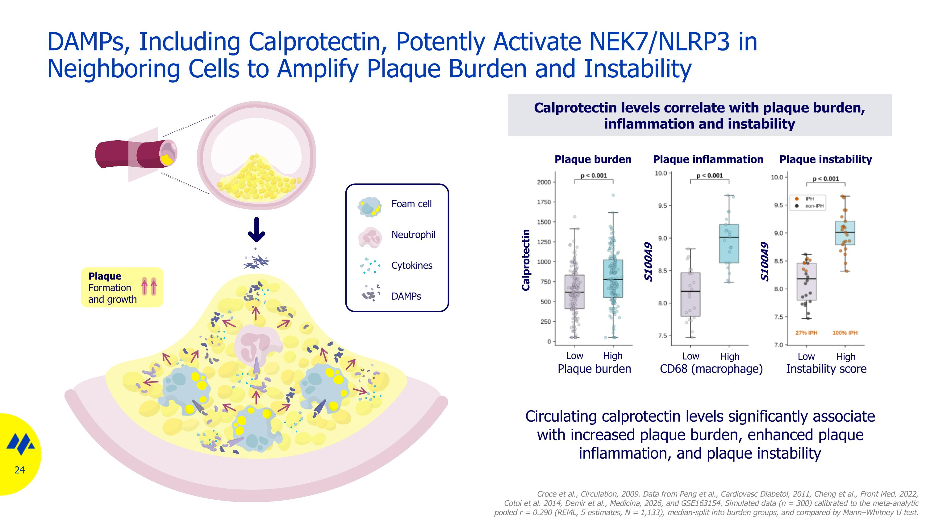
DAMPs, Including Calprotectin, Potently Activate NEK7/NLRP3 in Neighboring Cells to Amplify Plaque Burden and Instability Calprotectin levels correlate with plaque burden, inflammation and instability Croce et al., Circulation, 2009. Data from Peng et al., Cardiovasc Diabetol, 2011, Cheng et al., Front Med, 2022, Cotoi et al. 2014, Demir et al., Medicina, 2026, and GSE163154. Simulated data (n = 300) calibrated to the meta-analytic pooled r = 0.290 (REML, 5 estimates, N = 1,133), median-split into burden groups, and compared by Mann–Whitney U test. Circulating calprotectin levels significantly associate with increased plaque burden, enhanced plaque inflammation, and plaque instability Calprotectin Low High Low High Low High Plaque burden Plaque inflammation Plaque instability Plaque burden Plaque Formation and growth Foam cell Neutrophil Cytokines DAMPs CD68 (macrophage) Instability score S100A9 S100A9

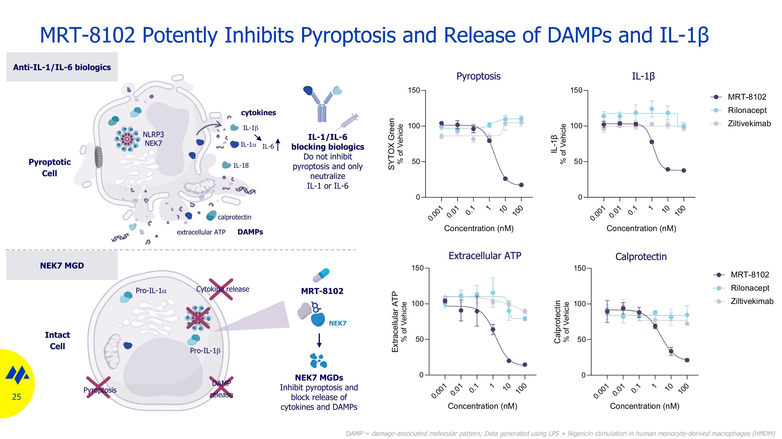
MRT-8102 Potently Inhibits Pyroptosis and Release of DAMPs and IL-1β Pro-IL-1a Pro-IL-1b Pyroptosis Cytokine release Anti-IL-1/IL-6 biologics Pyroptotic Cell Intact Cell NLRP3 NEK7 IL-1a IL-18 IL-1b NEK7 MRT-8102 DAMP release calprotectin NEK7 MGD IL-1/IL-6 blocking biologics Do not inhibit pyroptosis and only neutralize IL-1 or IL-6 IL-6 NEK7 MGDs Inhibit pyroptosis and block release of cytokines and DAMPs extracellular ATP cytokines DAMPs Pyroptosis IL-1β Extracellular ATP Calprotectin DAMP = damage-associated molecular pattern; Data generated using LPS + Nigericin stimulation in human monocyte-derived macrophages (hMDM)

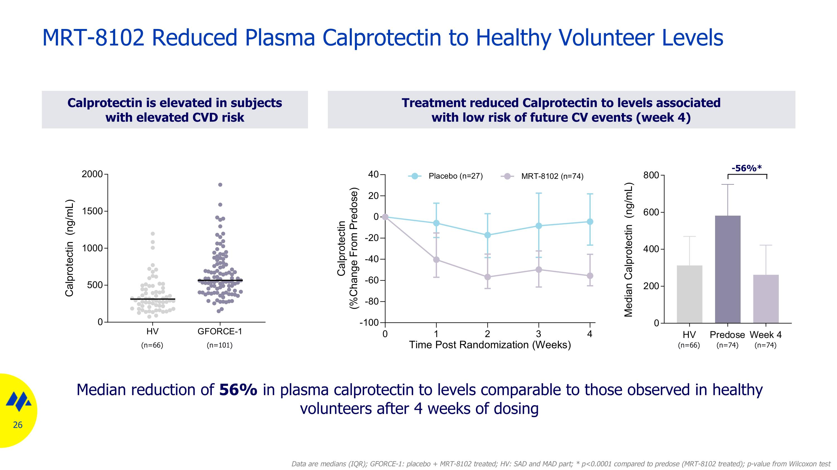
Calprotectin is elevated in subjects with elevated CVD risk Treatment reduced Calprotectin to levels associated with low risk of future CV events (week 4) MRT-8102 Reduced Plasma Calprotectin to Healthy Volunteer Levels Median reduction of 56% in plasma calprotectin to levels comparable to those observed in healthy volunteers after 4 weeks of dosing -56%* (n=66) (n=101) (n=66) (n=74) (n=74) Data are medians (IQR); GFORCE-1: placebo + MRT-8102 treated; HV: SAD and MAD part; * p<0.0001 compared to predose (MRT-8102 treated); p-value from Wilcoxon test

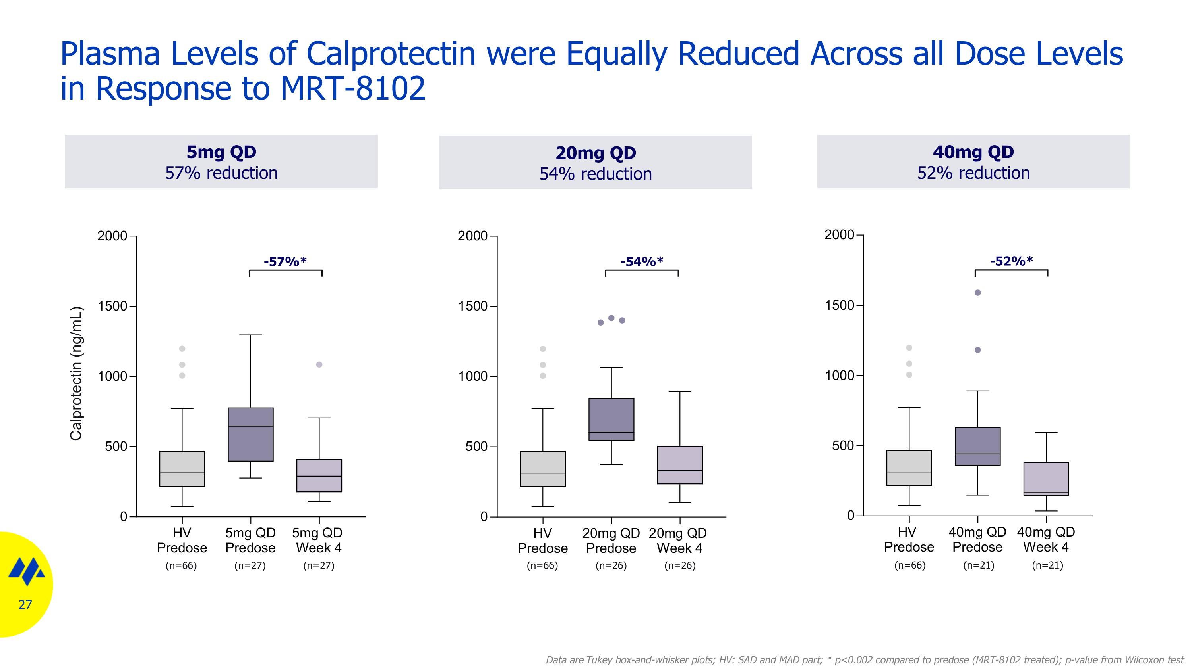
Plasma Levels of Calprotectin were Equally Reduced Across all Dose Levels in Response to MRT-8102 5mg QD 57% reduction 40mg QD 52% reduction 20mg QD 54% reduction Data are Tukey box-and-whisker plots; HV: SAD and MAD part; * p<0.002 compared to predose (MRT-8102 treated); p-value from Wilcoxon test Calprotectin (ng/mL) (n=66) (n=26) (n=26) (n=66) (n=21) (n=21) (n=66) (n=27) (n=27) -52%* -54%* -57%*

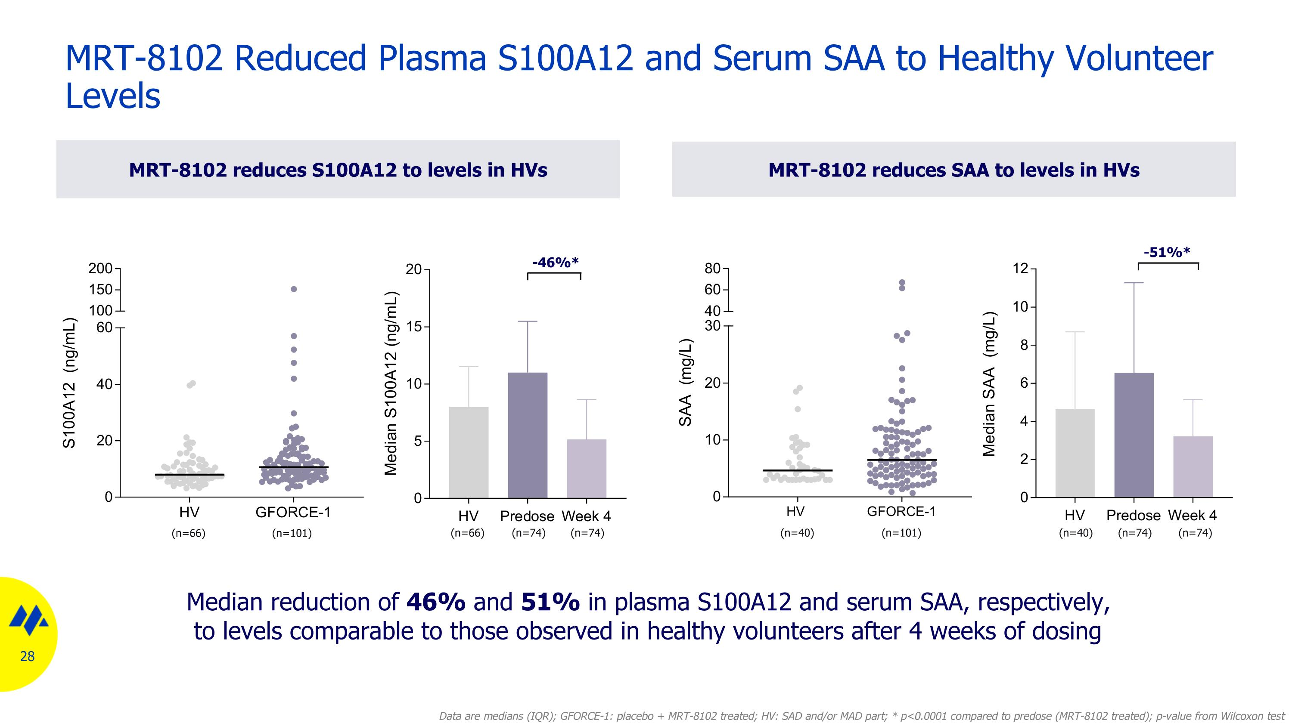
MRT-8102 Reduced Plasma S100A12 and Serum SAA to Healthy Volunteer Levels Median reduction of 46% and 51% in plasma S100A12 and serum SAA, respectively, to levels comparable to those observed in healthy volunteers after 4 weeks of dosing MRT-8102 reduces S100A12 to levels in HVs Data are medians (IQR); GFORCE-1: placebo + MRT-8102 treated; HV: SAD and/or MAD part; * p<0.0001 compared to predose (MRT-8102 treated); p-value from Wilcoxon test -46%* (n=66) (n=101) (n=66) (n=74) (n=74) MRT-8102 reduces SAA to levels in HVs (n=40) (n=101) (n=40) (n=74) (n=74) -51%*

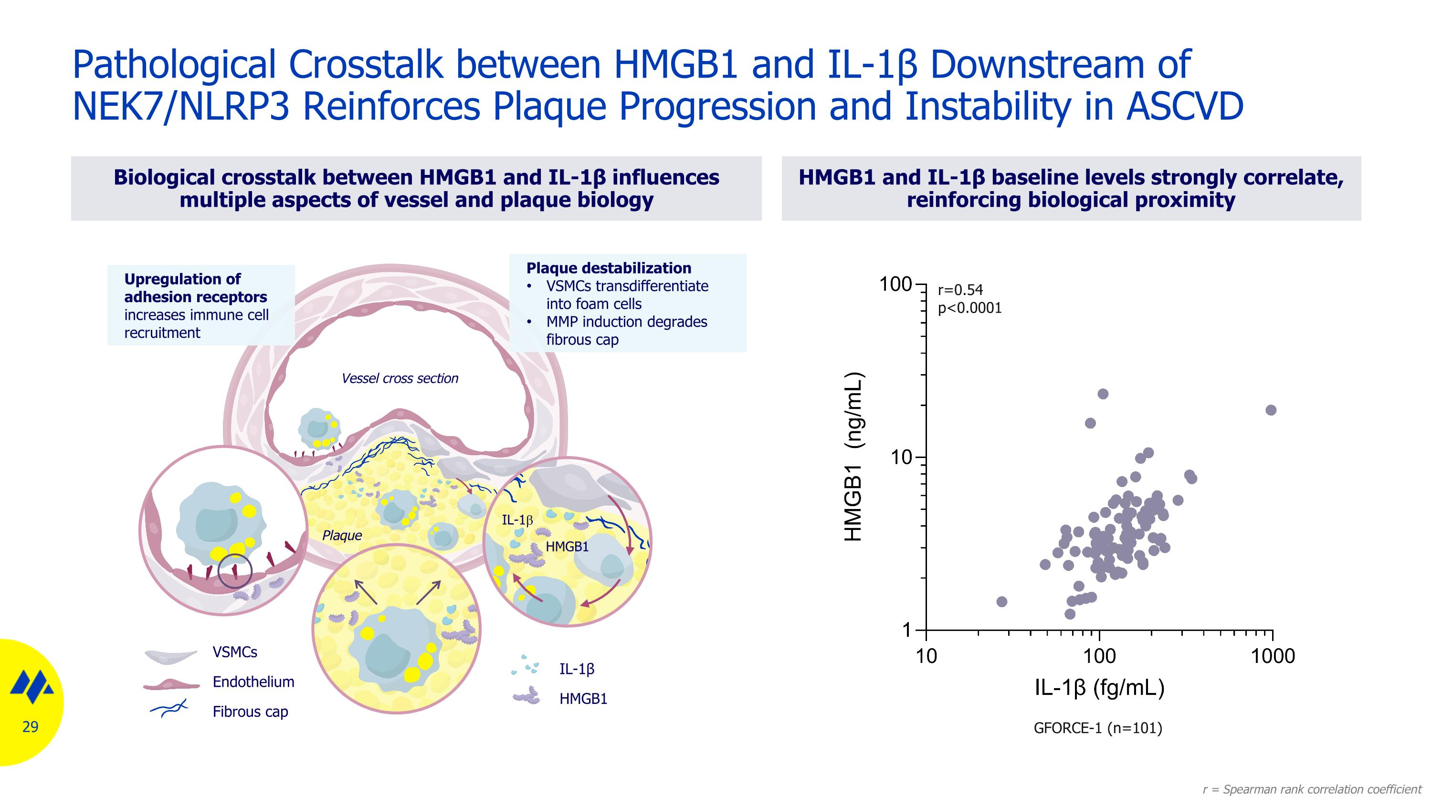
Biological crosstalk between HMGB1 and IL-1β influences multiple aspects of vessel and plaque biology HMGB1 and IL-1β baseline levels strongly correlate, reinforcing biological proximity Pathological Crosstalk between HMGB1 and IL-1β Downstream of NEK7/NLRP3 Reinforces Plaque Progression and Instability in ASCVD Plaque Upregulation of adhesion receptors increases immune cell recruitment Plaque destabilization VSMCs transdifferentiate into foam cells MMP induction degrades fibrous cap IL-1β HMGB1 VSMCs Endothelium Fibrous cap Vessel cross section IL-1b HMGB1 r=0.54 p<0.0001 r = Spearman rank correlation coefficient GFORCE-1 (n=101)

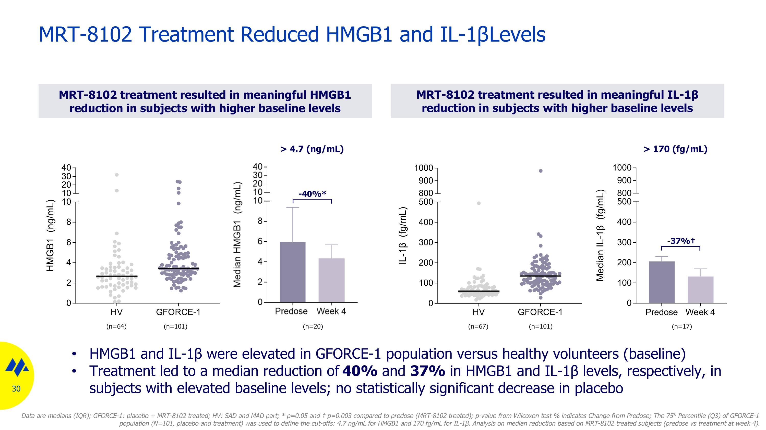
MRT-8102 treatment resulted in meaningful HMGB1 reduction in subjects with higher baseline levels MRT-8102 Treatment Reduced HMGB1 and IL-1β Levels (n=64) (n=101) > 4.7 (ng/mL) (n=20) -40%* (n=67) (n=101) (n=17) > 170 (fg/mL) MRT-8102 treatment resulted in meaningful IL-1β reduction in subjects with higher baseline levels HMGB1 and IL-1β were elevated in GFORCE-1 population versus healthy volunteers (baseline) Treatment led to a median reduction of 40% and 37% in HMGB1 and IL-1β levels, respectively, in subjects with elevated baseline levels; no statistically significant decrease in placebo Data are medians (IQR); GFORCE-1: placebo + MRT-8102 treated; HV: SAD and MAD part; * p=0.05 and  p=0.003 compared to predose (MRT-8102 treated); p-value from Wilcoxon test % indicates Change from Predose; The 75th Percentile (Q3) of GFORCE-1 population (N=101, placebo and treatment) was used to define the cut-offs: 4.7 ng/mL for HMGB1 and 170 fg/mL for IL-1β. Analysis on median reduction based on MRT-8102 treated subjects (predose vs treatment at week 4). -37%

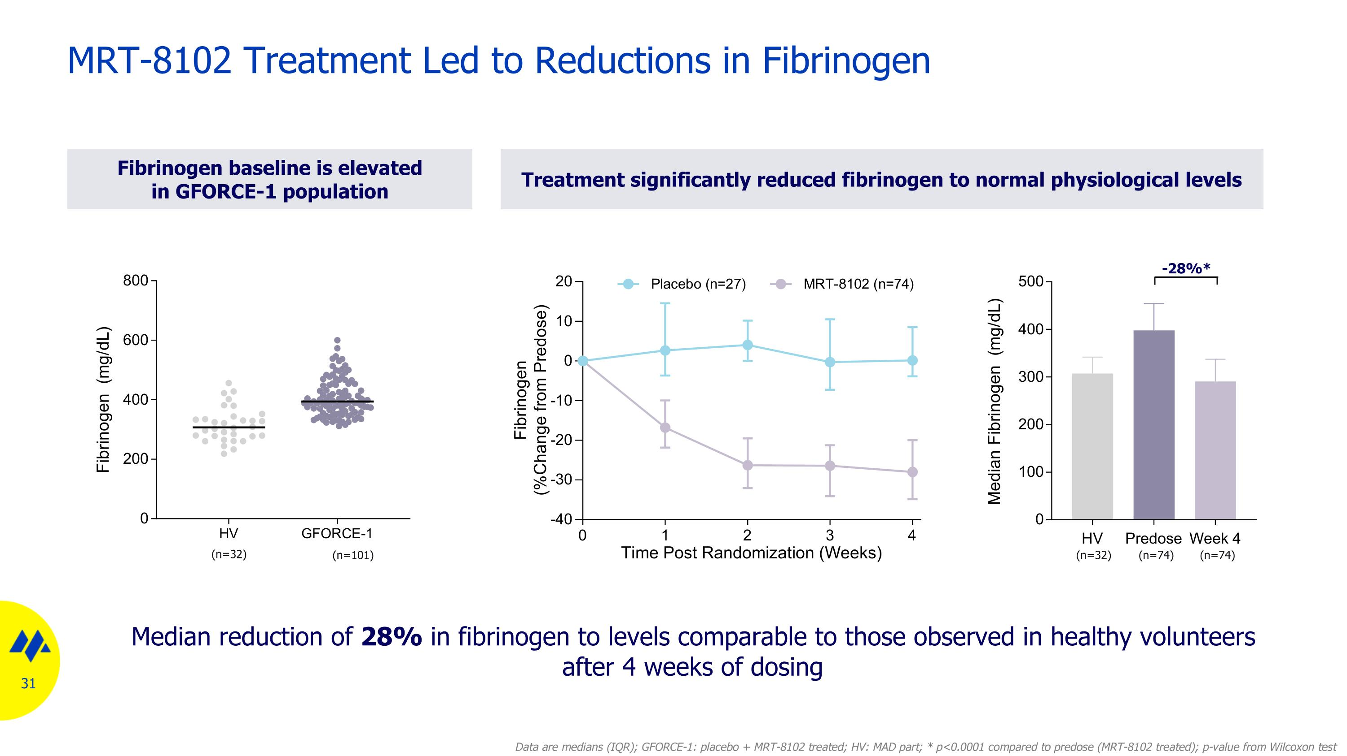
Treatment significantly reduced fibrinogen to normal physiological levels MRT-8102 Treatment Led to Reductions in Fibrinogen Fibrinogen baseline is elevated in GFORCE-1 population Median reduction of 28% in fibrinogen to levels comparable to those observed in healthy volunteers after 4 weeks of dosing (n=32) (n=74) (n=74) -28%* (n=32) (n=101) Data are medians (IQR); GFORCE-1: placebo + MRT-8102 treated; HV: MAD part; * p<0.0001 compared to predose (MRT-8102 treated); p-value from Wilcoxon test

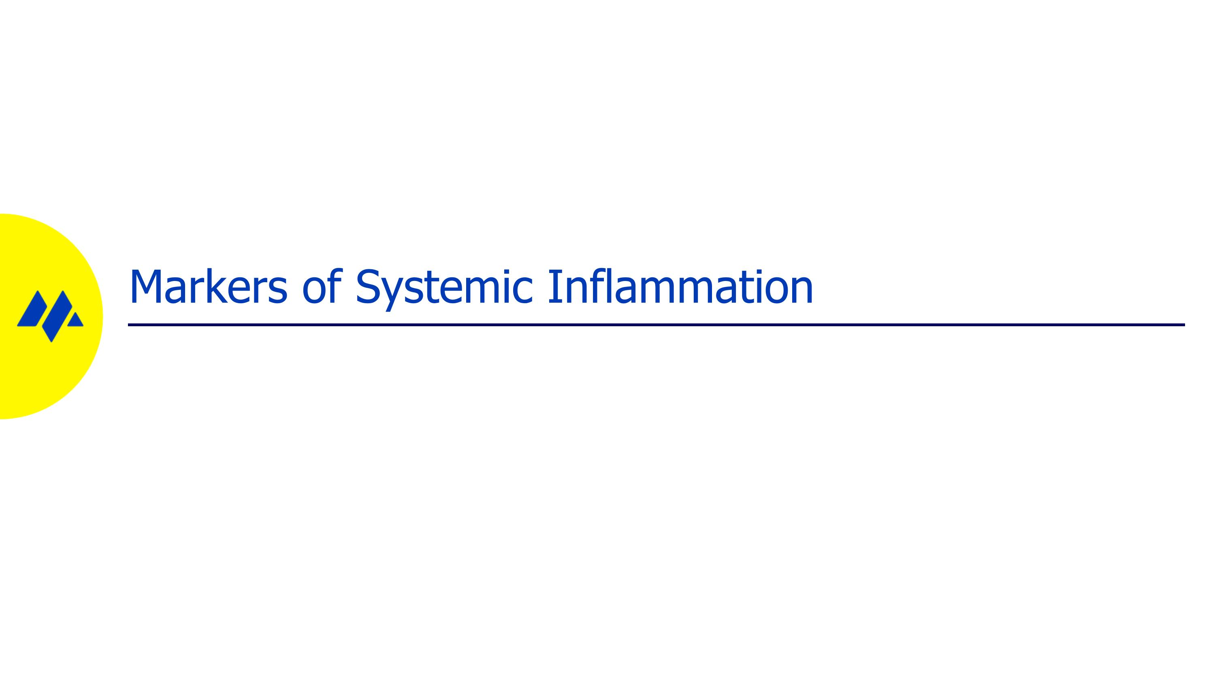
Markers of Systemic Inflammation

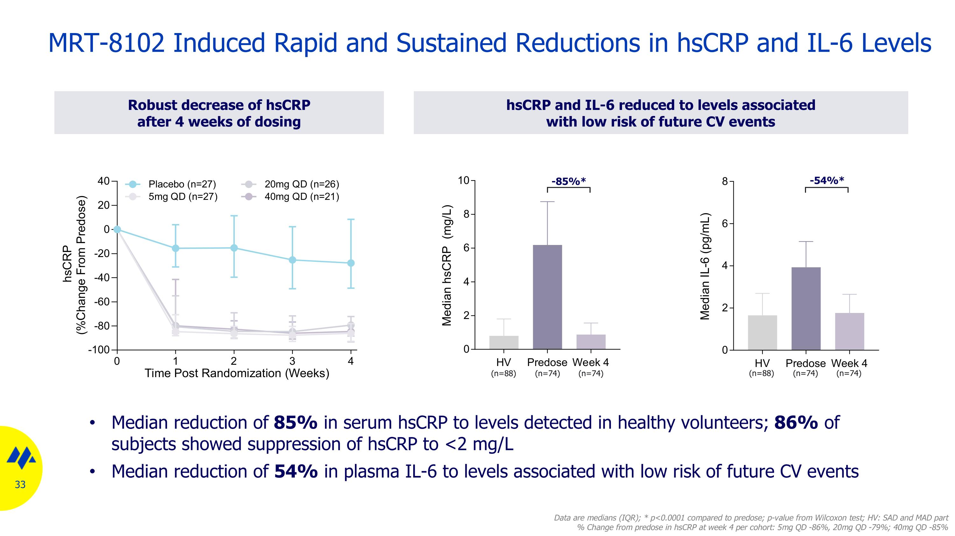
MRT-8102 Induced Rapid and Sustained Reductions in hsCRP and IL-6 Levels Robust decrease of hsCRP after 4 weeks of dosing Data are medians (IQR); * p<0.0001 compared to predose; p-value from Wilcoxon test; HV: SAD and MAD part % Change from predose in hsCRP at week 4 per cohort: 5mg QD -86%, 20mg QD -79%; 40mg QD -85% hsCRP and IL-6 reduced to levels associated ?with low risk of future CV events Median reduction of 85% in serum hsCRP to levels detected in healthy volunteers; 86% of subjects showed suppression of hsCRP to <2 mg/L Median reduction of 54% in plasma IL-6 to levels associated with low risk of future CV events -85%* -54%* (n=88) (n=74) (n=74) (n=88) (n=74) (n=74)

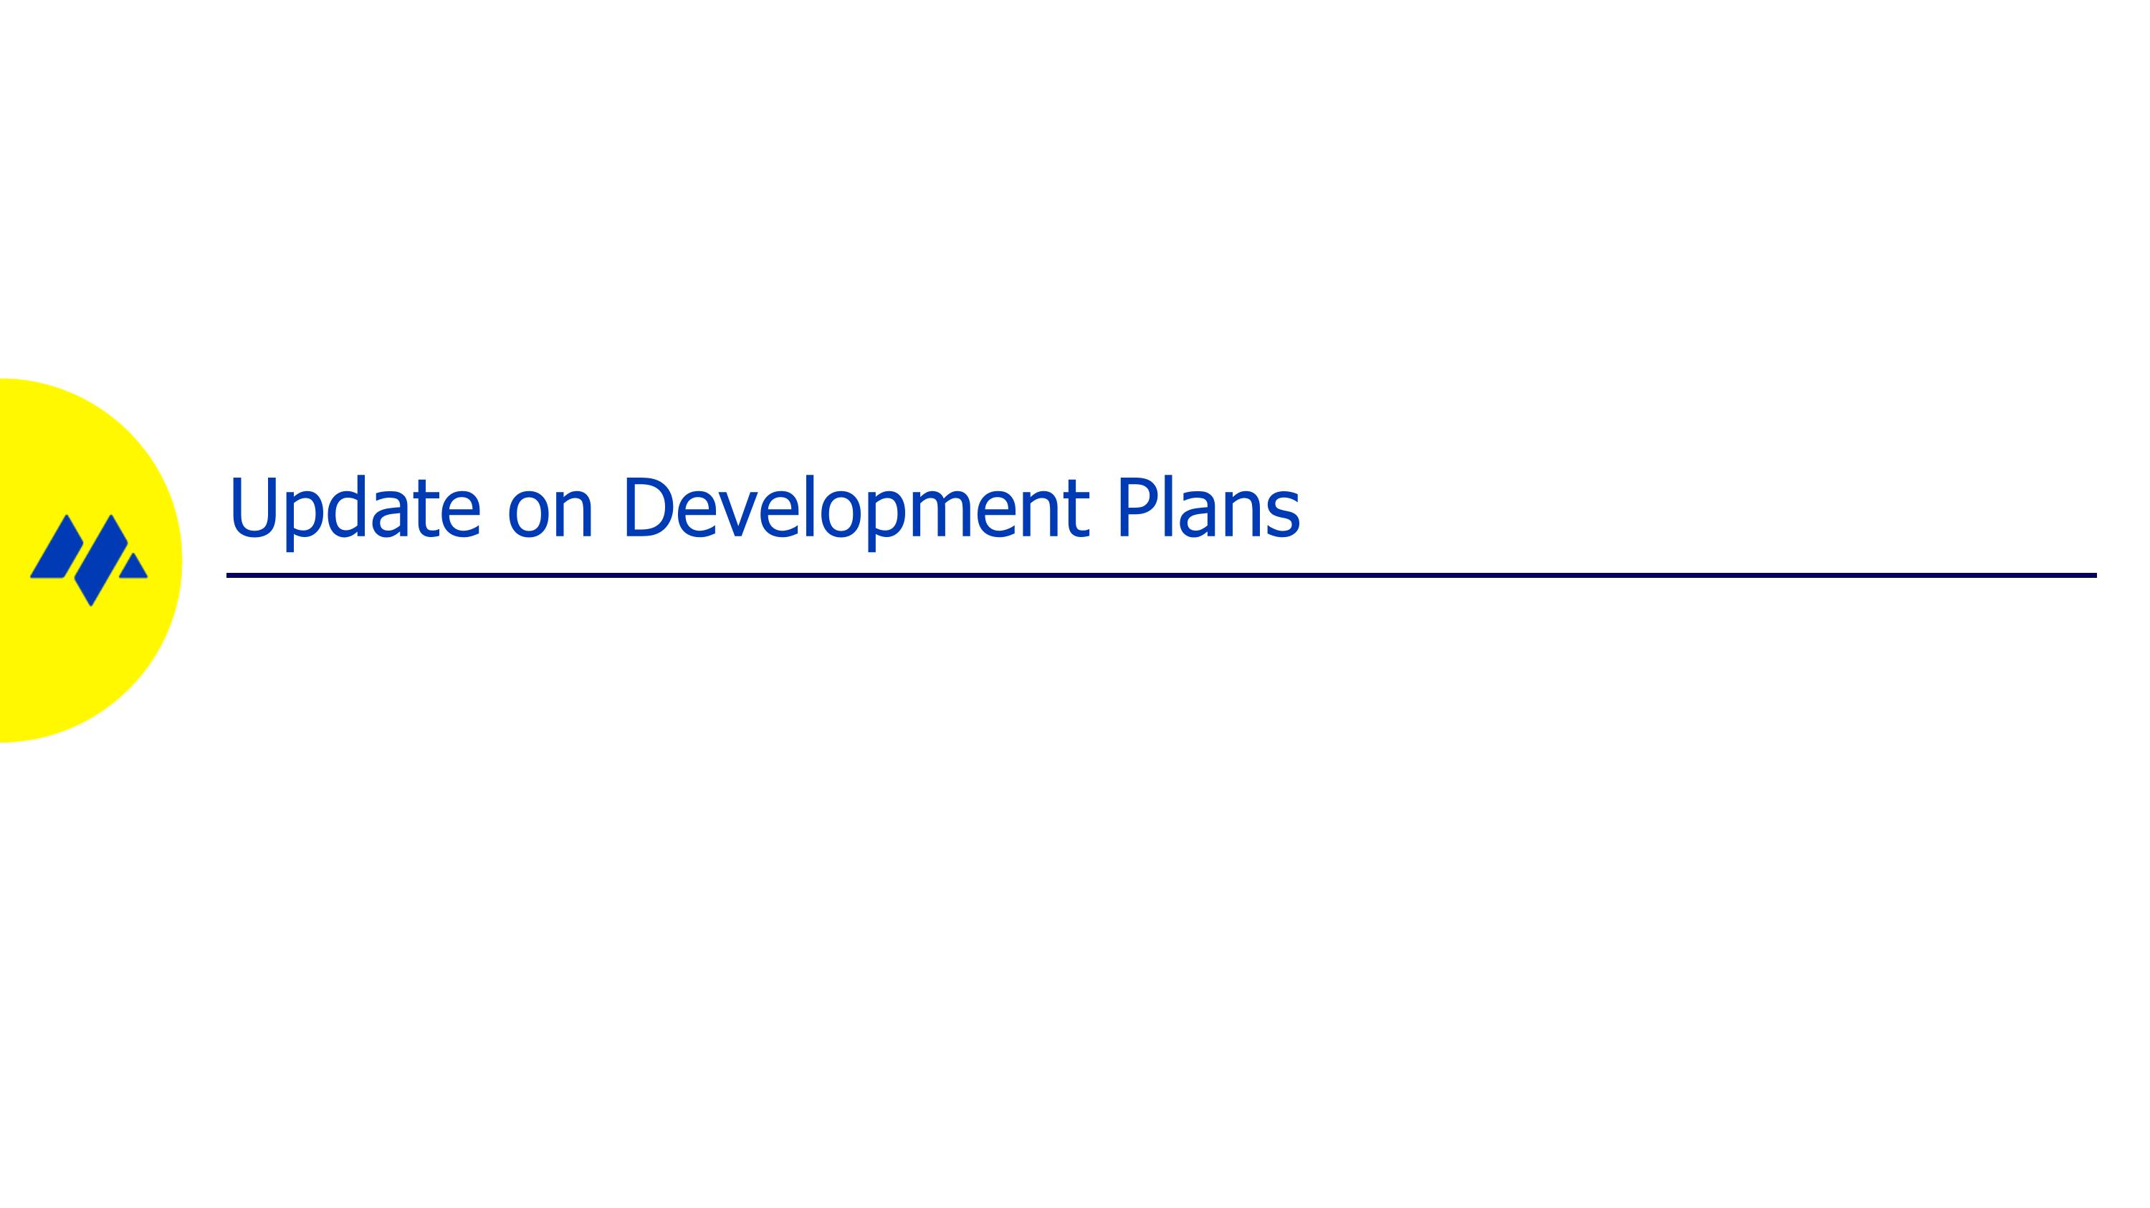
Update on Development Plans

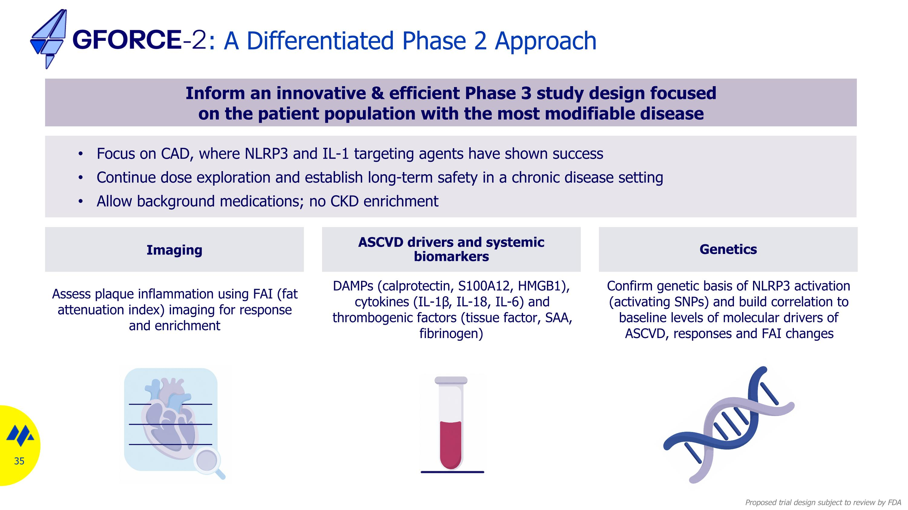
: A Differentiated Phase 2 Approach Proposed trial design subject to review by FDA Inform an innovative & efficient Phase 3 study design focused on the patient population with the most modifiable disease ASCVD drivers and systemic biomarkers Imaging Genetics DAMPs (calprotectin, S100A12, HMGB1), cytokines (IL-1β, IL-18, IL-6) and thrombogenic factors (tissue factor, SAA, fibrinogen) Assess plaque inflammation using FAI (fat attenuation index) imaging for response and enrichment Confirm genetic basis of NLRP3 activation (activating SNPs) and build correlation to baseline levels of molecular drivers of ASCVD, responses and FAI changes Focus on CAD, where NLRP3 and IL-1 targeting agents have shown success Continue dose exploration and establish long-term safety in a chronic disease setting Allow background medications; no CKD enrichment

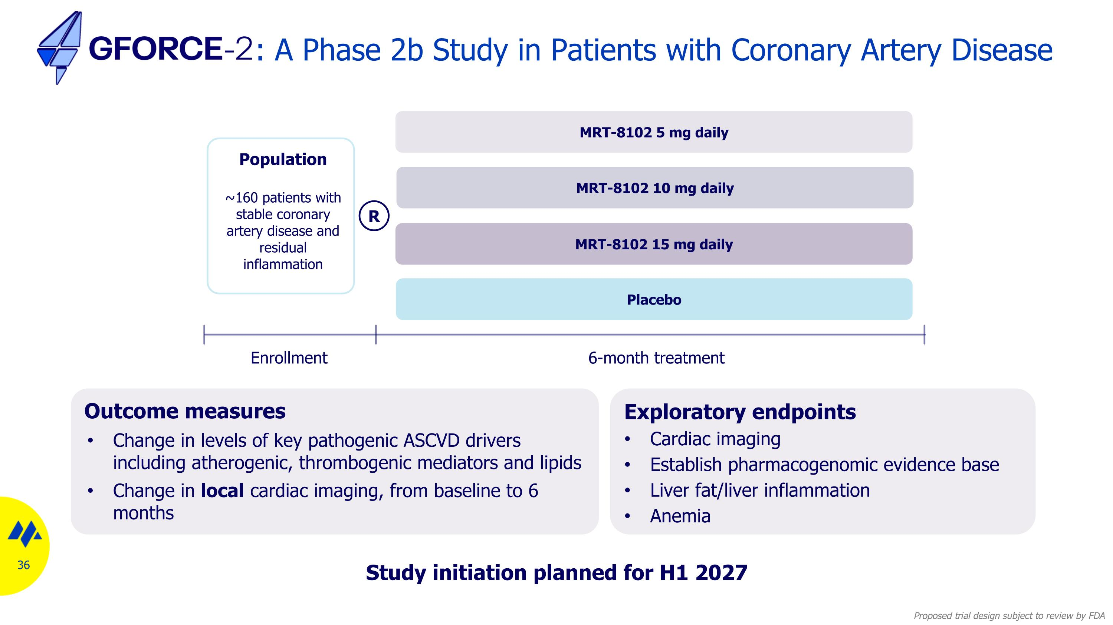
: A Phase 2b Study in Patients with Coronary Artery Disease Outcome measures Change in levels of key pathogenic ASCVD drivers including atherogenic, thrombogenic mediators and lipids Change in local cardiac imaging, from baseline to 6 months Exploratory endpoints Cardiac imaging Establish pharmacogenomic evidence base Liver fat/liver inflammation Anemia MRT-8102 5 mg daily MRT-8102 10 mg daily Placebo Enrollment 6-month treatment Population ~160 patients with stable coronary artery disease and residual inflammation R MRT-8102 15 mg daily Study initiation planned for H1 2027 Proposed trial design subject to review by FDA

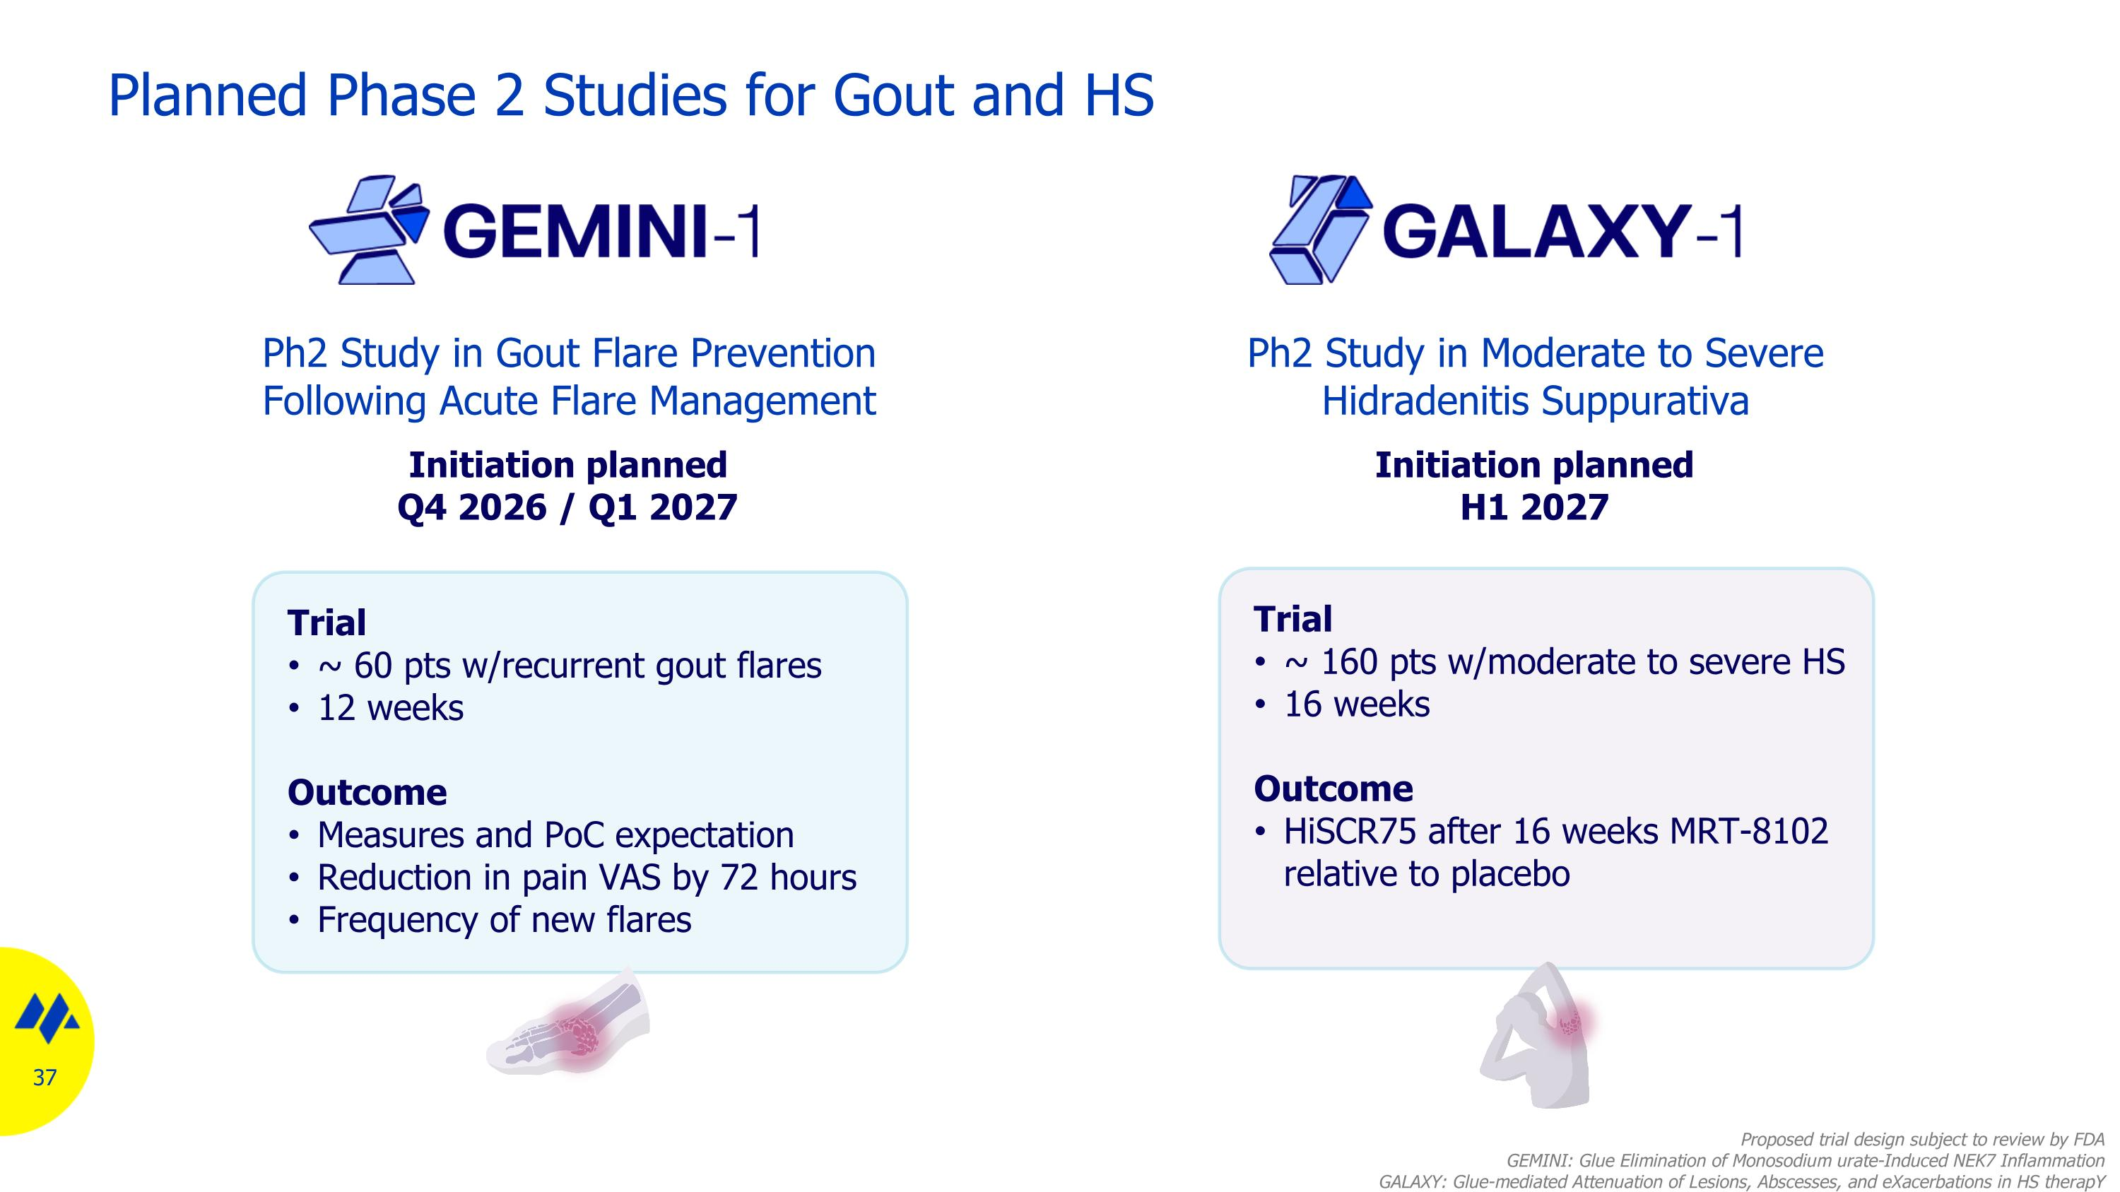
Ph2 Study in Gout Flare Prevention Following Acute Flare Management Initiation planned Q4 2026 / Q1 2027 Trial ~ 60 pts w/recurrent gout flares 12 weeks Outcome Measures and PoC expectation Reduction in pain VAS by 72 hours Frequency of new flares Ph2 Study in Moderate to Severe Hidradenitis Suppurativa Trial ~ 160 pts w/moderate to severe HS 16 weeks Outcome HiSCR75 after 16 weeks MRT-8102 relative to placebo Initiation planned H1 2027 Planned Phase 2 Studies for Gout and HS Proposed trial design subject to review by FDA GEMINI: Glue Elimination of Monosodium urate-Induced NEK7 Inflammation GALAXY: Glue-mediated Attenuation of Lesions, Abscesses, and eXacerbations in HS therapY

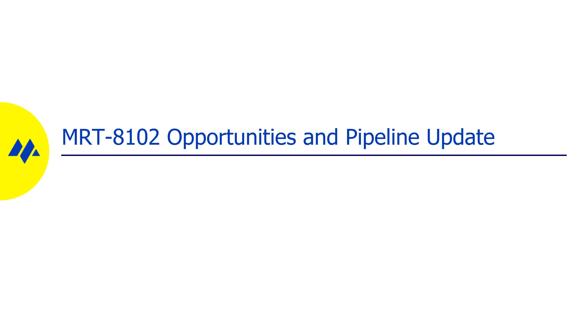
MRT-8102 Opportunities and Pipeline Update

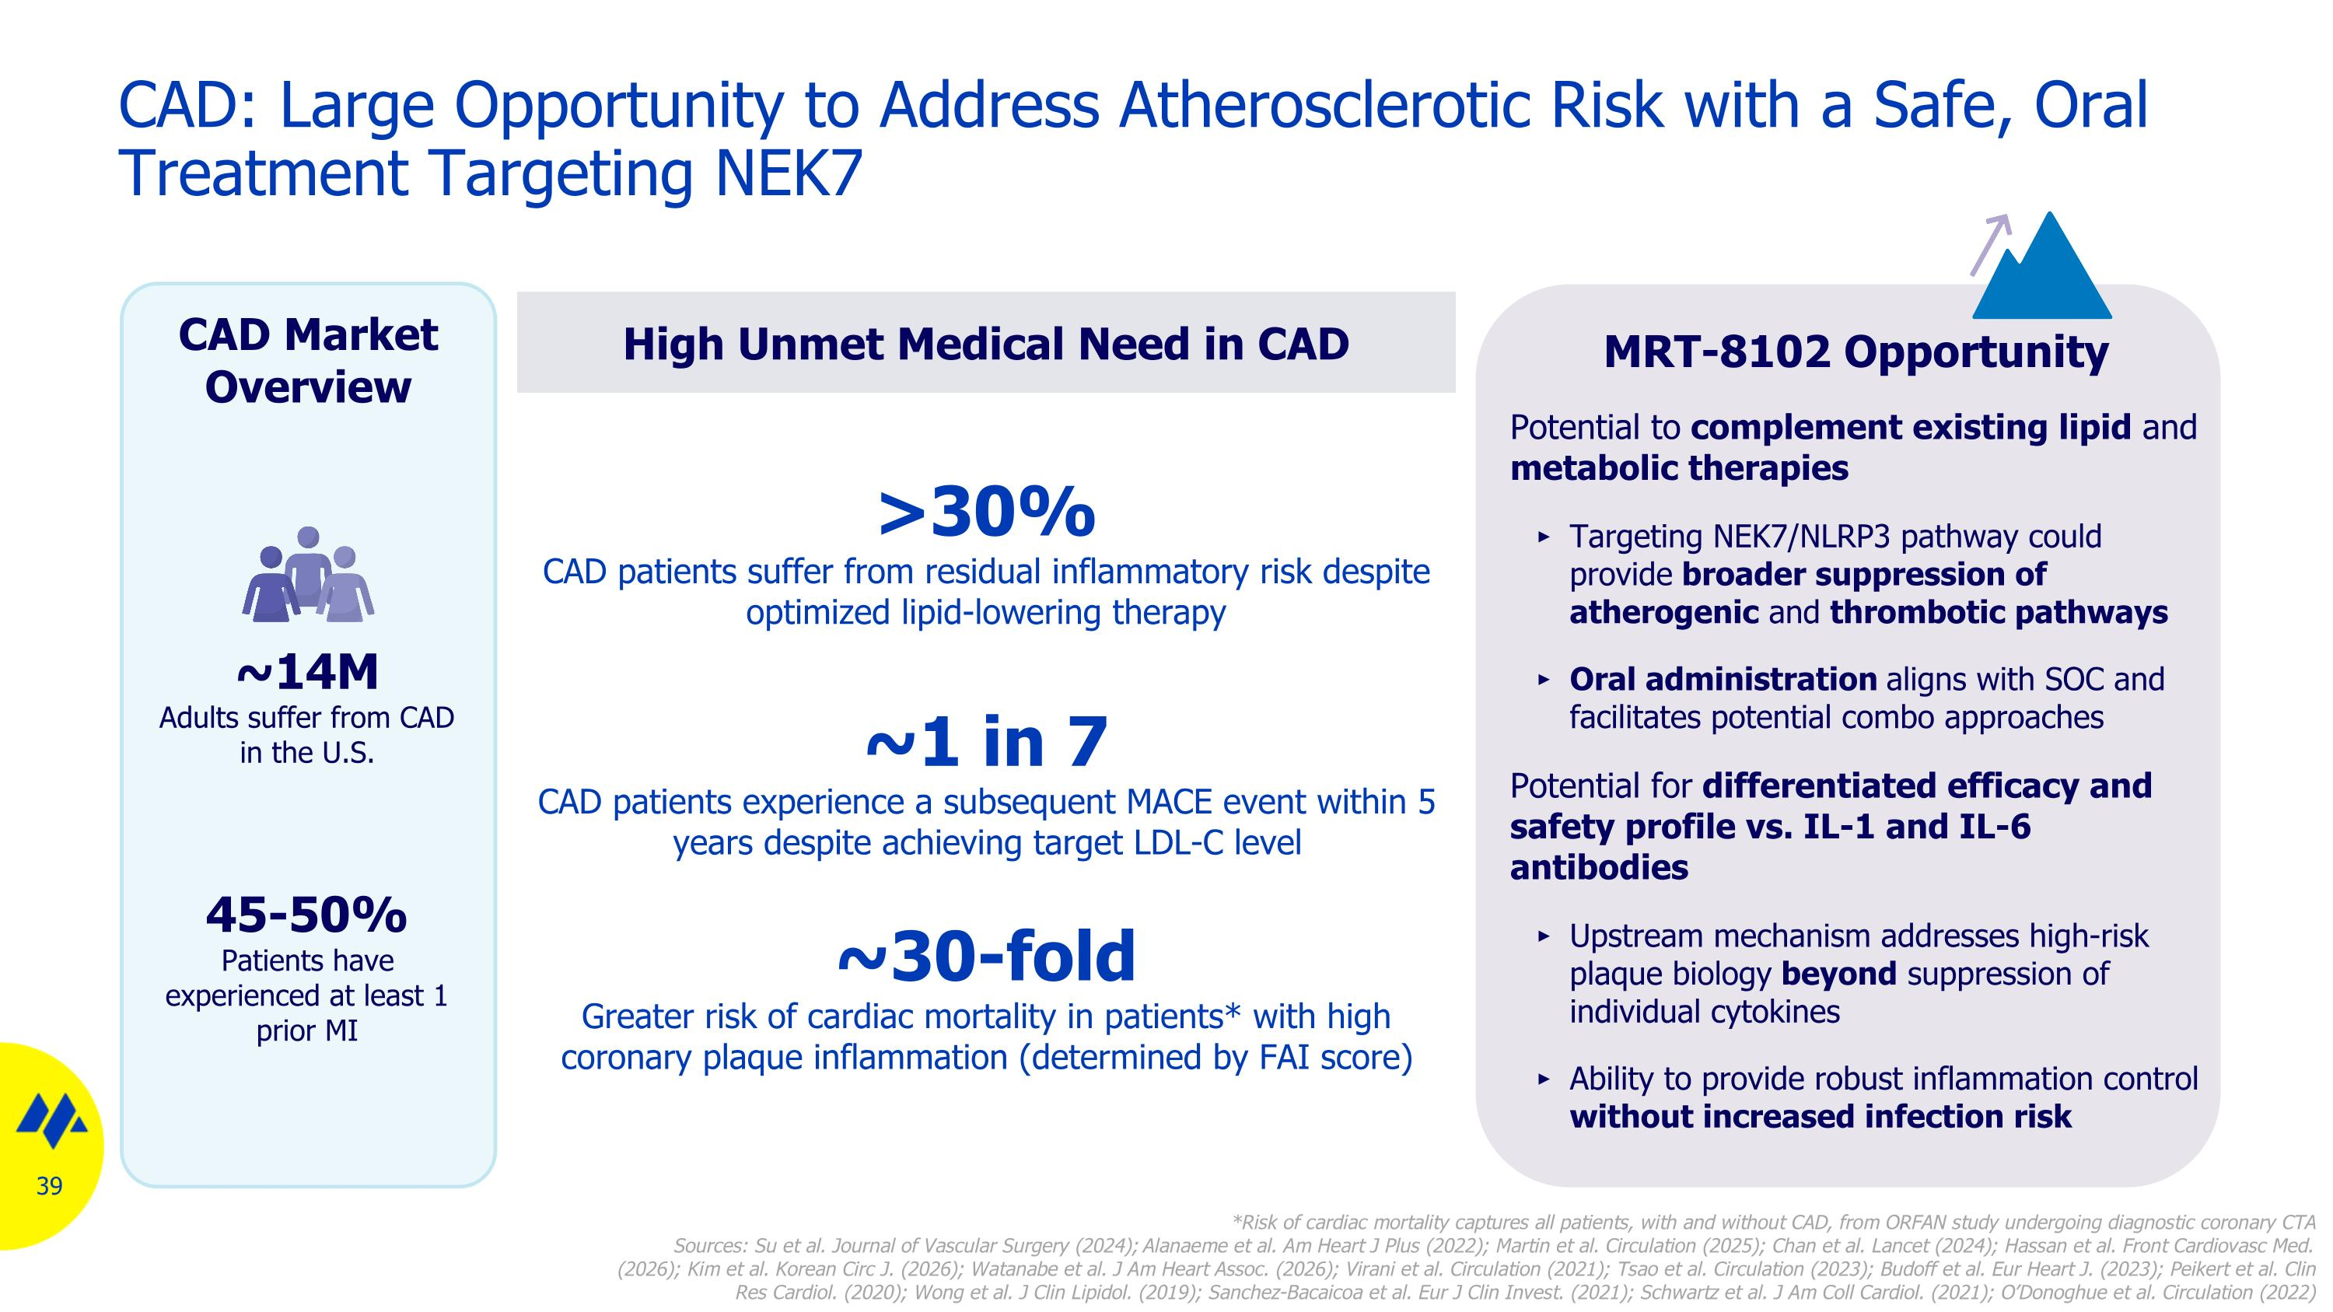
CAD: Large Opportunity to Address Atherosclerotic Risk with a Safe, Oral Treatment Targeting NEK7 MRT-8102 Opportunity Potential to complement existing lipid and metabolic therapies Targeting NEK7/NLRP3 pathway could provide broader suppression of atherogenic and thrombotic pathways Oral administration aligns with SOC and facilitates potential combo approaches Potential for differentiated efficacy and safety profile vs. IL-1 and IL-6 antibodies Upstream mechanism addresses high-risk plaque biology beyond suppression of individual cytokines Ability to provide robust inflammation control without increased infection risk High Unmet Medical Need in CAD CAD Market Overview ~14M Adults suffer from CAD in the U.S. 45-50% Patients have experienced at least 1 prior MI ~1 in 7 CAD patients experience a subsequent MACE event within 5 years despite achieving target LDL-C level >30% CAD patients suffer from residual inflammatory risk despite optimized lipid-lowering therapy ~30-fold Greater risk of cardiac mortality in patients* with high coronary plaque inflammation (determined by FAI score) *Risk of cardiac mortality captures all patients, with and without CAD, from ORFAN study undergoing diagnostic coronary CTA Sources: Su et al. Journal of Vascular Surgery (2024); Alanaeme et al. Am Heart J Plus (2022); Martin et al. Circulation (2025); Chan et al. Lancet (2024); Hassan et al. Front Cardiovasc Med. (2026); Kim et al. Korean Circ J. (2026); Watanabe et al. J Am Heart Assoc. (2026); Virani et al. Circulation (2021); Tsao et al. Circulation (2023); Budoff et al. Eur Heart J. (2023); Peikert et al. Clin Res Cardiol. (2020); Wong et al. J Clin Lipidol. (2019); Sanchez-Bacaicoa et al. Eur J Clin Invest. (2021); Schwartz et al. J Am Coll Cardiol. (2021); O’Donoghue et al. Circulation (2022)

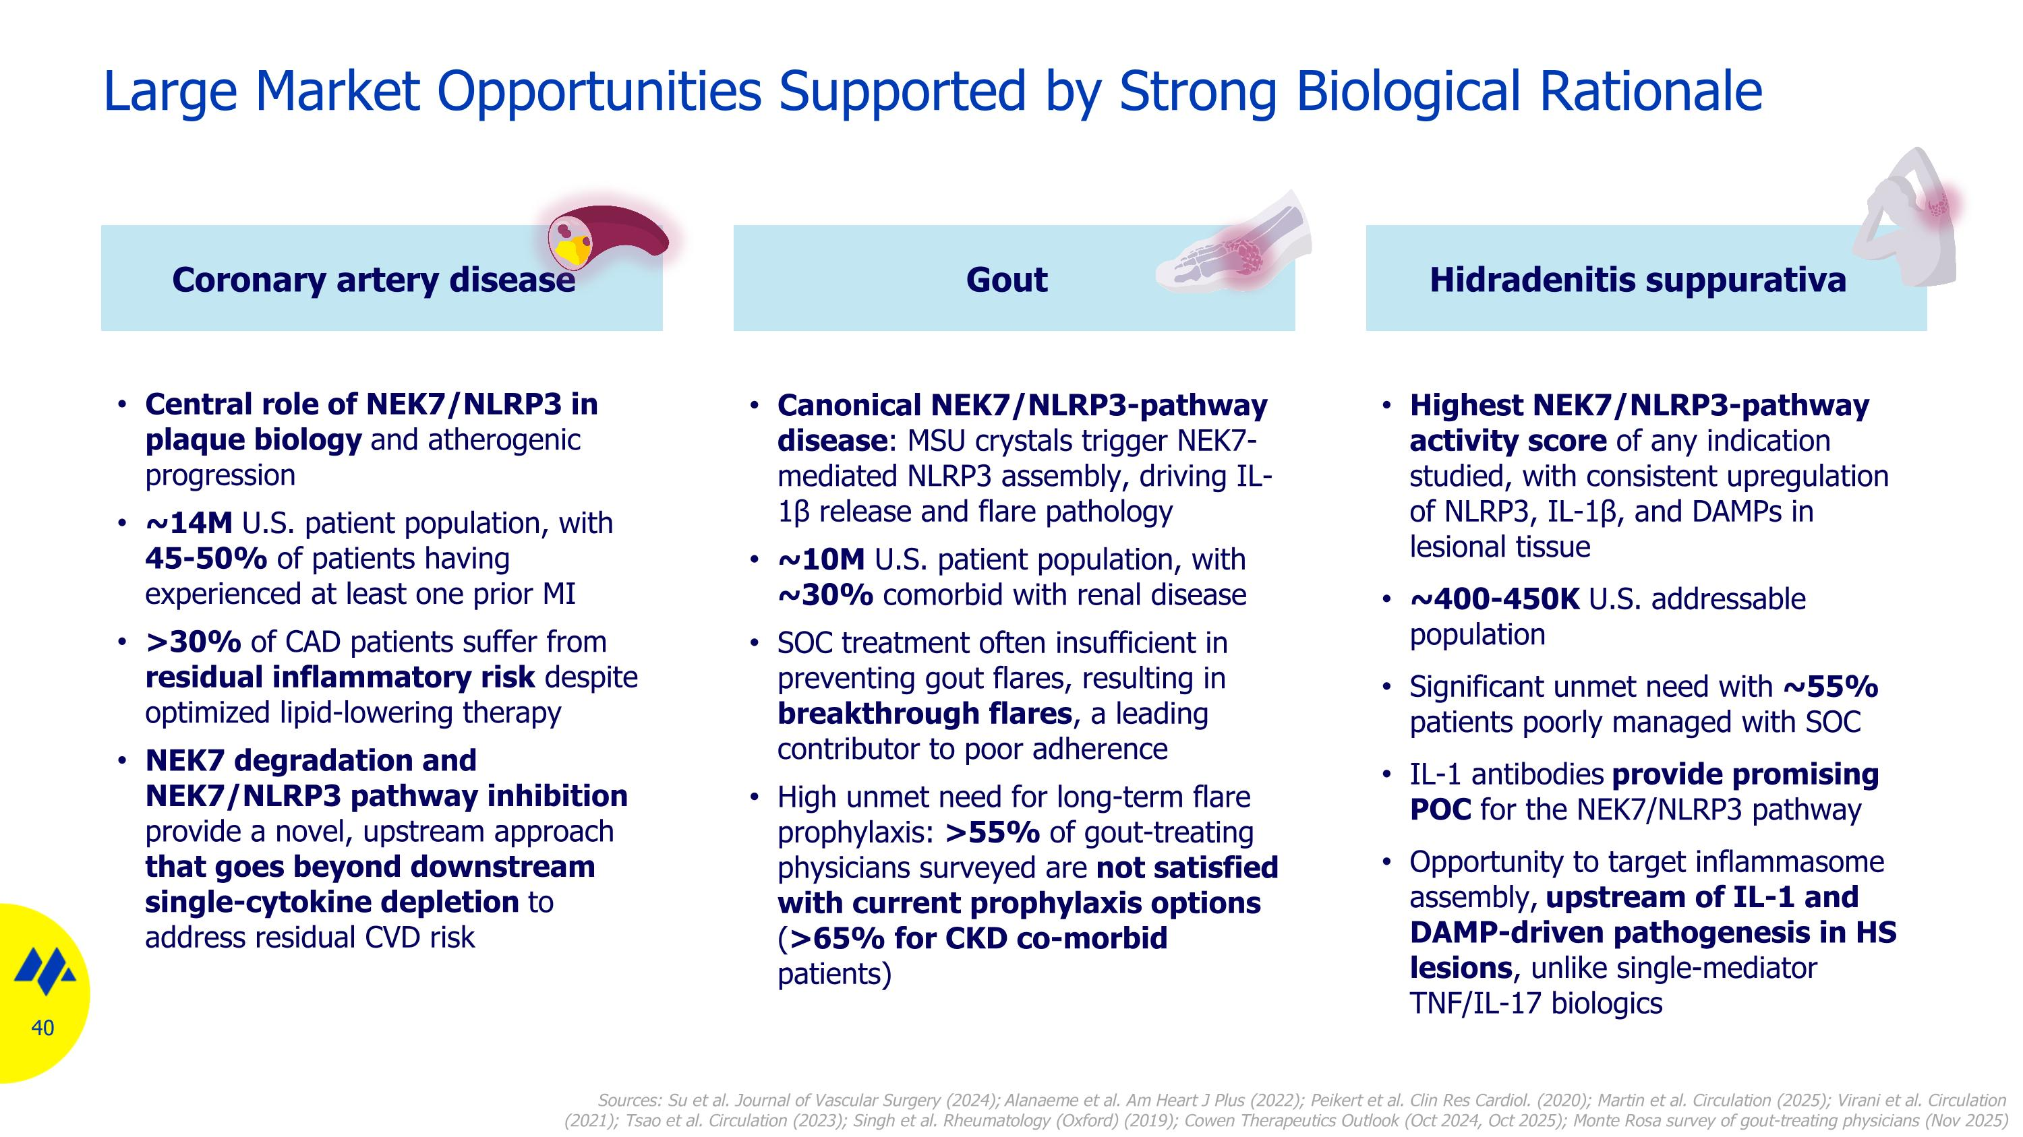
Large Market Opportunities Supported by Strong Biological Rationale Hidradenitis suppurativa Highest NEK7/NLRP3-pathway activity score of any indication studied, with consistent upregulation of NLRP3, IL-1β, and DAMPs in lesional tissue ~400-450K U.S. addressable population Significant unmet need with ~55% patients poorly managed with SOC IL-1 antibodies provide promising POC for the NEK7/NLRP3 pathway Opportunity to target inflammasome assembly, upstream of IL-1 and DAMP-driven pathogenesis in HS lesions, unlike single-mediator TNF/IL-17 biologics Coronary artery disease Central role of NEK7/NLRP3 in plaque biology and atherogenic progression ~14M U.S. patient population, with 45-50% of patients having experienced at least one prior MI >30% of CAD patients suffer from residual inflammatory risk despite optimized lipid-lowering therapy NEK7 degradation and NEK7/NLRP3 pathway inhibition provide a novel, upstream approach that goes beyond downstream single-cytokine depletion to address residual CVD risk Gout Canonical NEK7/NLRP3-pathway disease: MSU crystals trigger NEK7-mediated NLRP3 assembly, driving IL-1β release and flare pathology ~10M U.S. patient population, with ~30% comorbid with renal disease SOC treatment often insufficient in preventing gout flares, resulting in breakthrough flares, a leading contributor to poor adherence High unmet need for long-term flare prophylaxis: >55% of gout-treating physicians surveyed are not satisfied with current prophylaxis options (>65% for CKD co-morbid patients) Sources: Su et al. Journal of Vascular Surgery (2024); Alanaeme et al. Am Heart J Plus (2022); Peikert et al. Clin Res Cardiol. (2020); Martin et al. Circulation (2025); Virani et al. Circulation (2021); Tsao et al. Circulation (2023); Singh et al. Rheumatology (Oxford) (2019); Cowen Therapeutics Outlook (Oct 2024, Oct 2025); Monte Rosa survey of gout-treating physicians (Nov 2025)

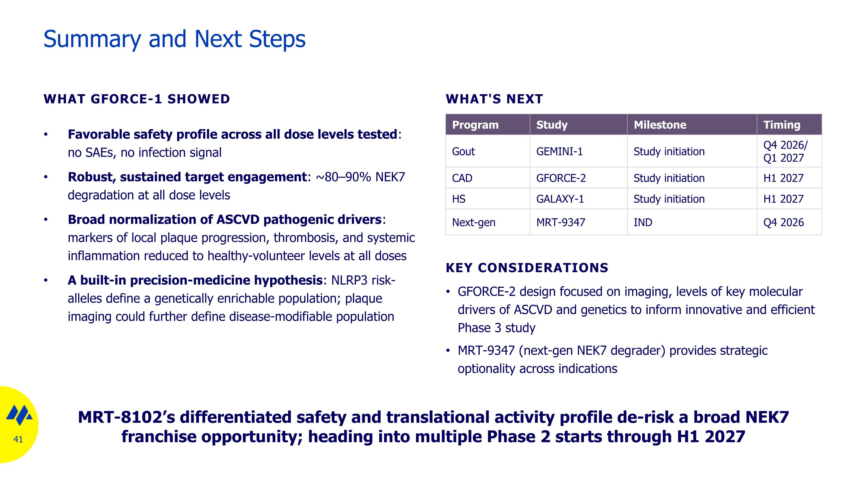
Summary and Next Steps WHAT GFORCE-1 SHOWED Favorable safety profile across all dose levels tested: no SAEs, no infection signal Robust, sustained target engagement: ~80–90% NEK7 degradation at all dose levels Broad normalization of ASCVD pathogenic drivers: markers of local plaque progression, thrombosis, and systemic inflammation reduced to healthy-volunteer levels at all doses A built-in precision-medicine hypothesis: NLRP3 risk-alleles define a genetically enrichable population; plaque imaging could further define disease-modifiable population WHAT'S NEXT Program Study Milestone Timing Gout GEMINI-1 Study initiation Q4 2026/ Q1 2027 CAD GFORCE-2 Study initiation H1 2027 HS GALAXY-1 Study initiation H1 2027 Next-gen MRT-9347 IND Q4 2026 KEY CONSIDERATIONS GFORCE-2 design focused on imaging, levels of key molecular drivers of ASCVD and genetics to inform innovative and efficient Phase 3 study MRT-9347 (next-gen NEK7 degrader) provides strategic optionality across indications MRT-8102’s differentiated safety and translational activity profile de-risk a broad NEK7 franchise opportunity; heading into multiple Phase 2 starts through H1 2027

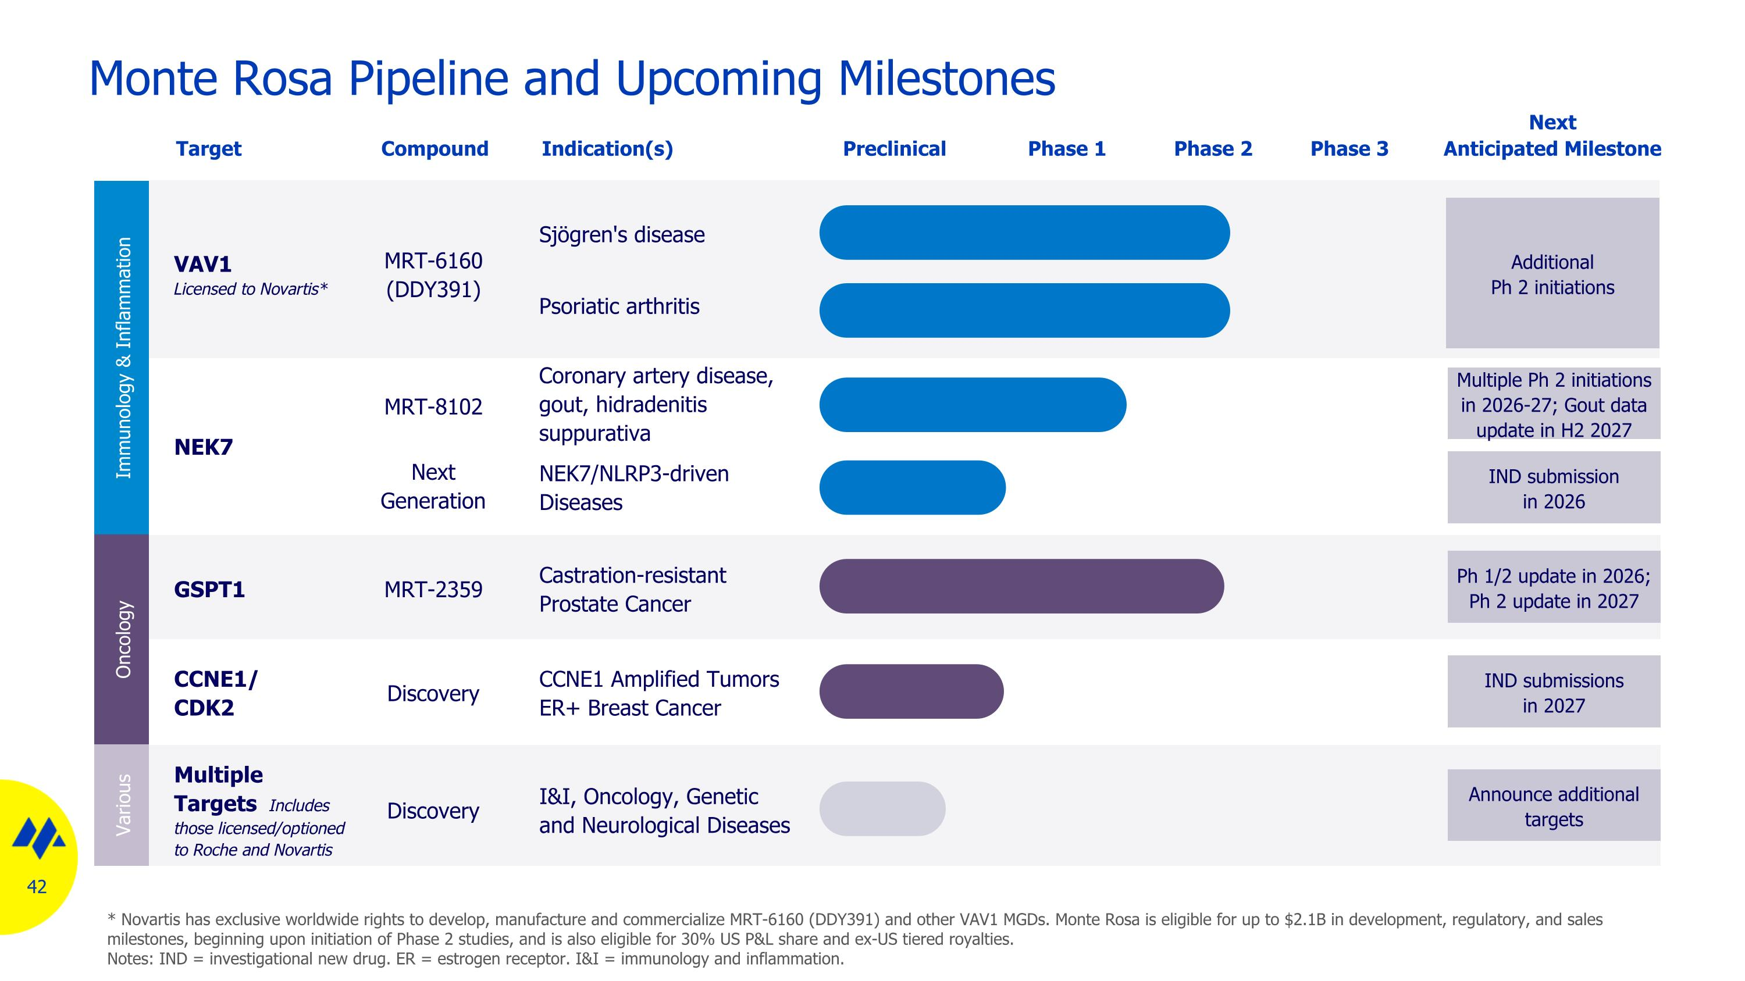
Monte Rosa Pipeline and Upcoming Milestones GSPT1 Castration-resistant Prostate Cancer NEK7/NLRP3-driven Diseases VAV1 Licensed to Novartis* Sjögren's disease Preclinical Target Indication(s) Ph 1/2 update in 2026; Ph 2 update in 2027 Next Anticipated Milestone Phase 1 Phase 2 Multiple Ph 2 initiations in 2026-27; Gout data update in H2 2027 Additional ?Ph 2 initiations Multiple Targets Includes those licensed/optioned to Roche and Novartis I&I, Oncology, Genetic and Neurological Diseases Announce additional targets NEK7 Compound MRT-2359 MRT-6160?(DDY391) MRT-8102 Discovery IND submission ?in 2026 Next ?Generation CCNE1/?CDK2 CCNE1 Amplified Tumors ER+ Breast Cancer IND submissions ?in 2027 Discovery Immunology & Inflammation Oncology Various * Novartis has exclusive worldwide rights to develop, manufacture and commercialize MRT-6160 (DDY391) and other VAV1 MGDs. Monte Rosa is eligible for up to $2.1B in development, regulatory, and sales milestones, beginning upon initiation of Phase 2 studies, and is also eligible for 30% US P&L share and ex-US tiered royalties. Notes: IND = investigational new drug. ER = estrogen receptor. I&I = immunology and inflammation. Phase 3 Coronary artery disease, gout, hidradenitis suppurativa Psoriatic arthritis


Q&A


Thank you

